**A**

**Project Report**

**on**

**Online Management Order System**

**Developed By**

***Martand Ghaskadvi [2205112130007]***

***Ebin Jose [2205112140029]***

***Saurabh Lodhi [2205112130013]***

**as**

**Partial Fulfillment ofSemester III of**

**Master of Computer Applications / Master of Science in information Technology**

**for A.Y. 2023 - 2024**

**Under the Guidance of**

**Prof. Faculty Name**

**Shikha Bansal Maam**

**Submitted To**

**Department of MCA/MScIT**

**Faculty of IT & Computer Science**

**PARUL University**





**CERTIFICATE**

This is to certify that **Mr./Ms.Martand Ghaskadvi, 2205112130007. ______________**and **Mr./Ms.Ebin Jose, 2205112140029. ______________Mr./Ms.Saurabh Lodhi, 2205112130013 ______________**students of Master of Computer Applications and/or Master of Science in Information Technology has satisfactorily completed the Minor Project on **“Project Title”** at**Faculty of IT & Computer Science,Parul University**as partialfulfillment of MCA and/or M.Sc. (IT) Semester III.

Seat No. 2205112130007, Date of Submission: ____________

2205112140029

2205112130012

_______________ _______________

Internal Guide Dean - FITCS

**Faculty of IT & Computer Science**

**PARUL University, Vadodara**

**INDEX**

|  |  |  |
| --- | --- | --- |
| **No.** | **Description** | **Page No.** |
| **1.** | **About Department of MCA** | **1** |
| **2.** | **Project Profile**  2.1 Project Definition  2.2 Project Description  2.3 Existing System / Work Environment  2.4 Problem Statements  2.5 Need for New System  2.6 Proposed System& Features  2.7 Scope  2.8 Outcomes  2.9 Tools & Technology used  2.10 Project Plan |  |
| **3.** | **Requirement Analysis**  3.1 Feasibility Study  3.2 Users of the System  3.3 Modules  3.4 Process Model  3.5 Hardware & Software Requirements  3.6 Use Cases  3.7 Use Case Diagram |  |
| **4.** | **Design**  4.1 Use Case Scenarios  4.2 Diagrams  4.2.1 UML / DFD  4.2.2 Entity Relationship Diagram  4.3 Data Dictionary |  |
| **5.** | **Implementation**  5.1 Form Layouts  5.2 Report Layouts  5.3 Coding Convention (Business Logic) |  |
| **6.** | **Testing**  6.1 Test Strategy  6.2 Test Cases |  |
| **7.** | **Future Enhancement** |  |
| **8.** | **Bibliography** |  |

2.1 Project Definition:-Online Product Management System

2.2 Project Overview:-The Online Product Management System is a web-based application designed to streamline and enhance the process of managing products throughout their lifecycle. It provides a user-friendly interface for businesses to efficiently manage product information, inventory, pricing, and other essential aspects, enabling them to make informed decisions and improve their overall product management process.

2.2.1 Objectives:-The primary objectives of the Online Product Management System are:

Centralized Product Information: Create a centralized repository for all product-related data, including descriptions, images, specifications, and categorizations. Efficient Inventory Management: Facilitate real-time monitoring of inventory levels, enabling businesses to optimize stock levels and prevent overstocking or stockouts Dynamic Pricing Control: Allow businesses to set and adjust pricing strategies based on factors such as demand, competition, and market trends. Lifecycle Tracking: Enable tracking of products throughout their lifecycle, from introduction to discontinuation, including updates, revisions, and end-of-life management. User Access Control: Implement role-based access control to ensure that only authorized users can manage product data, ensuring data security and integrity. Reporting and Analytics: Provide insightful reports and analytics on product performance, sales trends, and inventory turnover to aid decision-making. Integration Capabilities: Allow integration with other business systems like e-commerce platforms, ERP systems, and POS systems to ensure data consistency across different touchpoints.

2.2.2 Features:-The Online Product Management System will include the following features:

Product Information Management (PIM): A comprehensive interface to create, edit, and manage detailed product information such as descriptions, images, attributes, and variants. Inventory Management: Real-time tracking of inventory levels, automatic alerts for low stock, and tools for managing restocking and inventory movement. Pricing Management: Flexible pricing controls, including bulk pricing, promotional pricing, and dynamic pricing adjustments. Lifecycle Tracking: Tools to manage different phases of a product's lifecycle, from introduction to end-of-life management. User Authentication and Authorization: Secure user registration and role-based access control to ensure data privacy. Search and Filtering: Robust search and filtering capabilities to quickly locate specific products based on various criteria. Analytics Dashboard: Interactive dashboards and reports showcasing key performance indicators, sales metrics, and inventory turnover. Integration APIs: APIs to facilitate integration with external systems like e-commerce platforms and ERP software.

2.2.3 Project Deliverables:- Fully functional web-based application accessible through standard web browsers. User documentation and training materials to ensure efficient system usage. Source code and database schema documentation for future maintenance and updates.

2.2.4 Project Timeline:-

Phase 1: Requirements and Planning (2 weeks) Gather detailed requirements from stakeholders. Define user roles and permissions. Plan system architecture and technology stack.

Phase 2: System Design and Development (8 weeks) Design the user interface and database schema. Develop core modules including PIM, inventory management, pricing controls, and user authentication. Implement integration APIs.

Phase 3: Testing and Quality Assurance (4 weeks). Conduct thorough testing of all features and functionalities .Identify and resolve any bugs or issues. Perform security and performance testing.

Phase 4: Deployment and Training (2 weeks) Deploy the application to a production environment. Provide user training and documentation.

Phase 5: Post-Deployment Support and Optimization (Ongoing) Address user feedback and make necessary improvements. Monitor system performance and scalability.

2.3 Existing System and/or Work Environment:-Before embarking on the development of an Online Product Management System, it's crucial to understand the existing system and work environment. This analysis provides insights into the pain points, challenges, and opportunities that the new system can address. Here's an overview of the existing system and work environment:

2.3.1 Existing System:

Currently, many businesses rely on manual methods or fragmented software solutions to manage their products, inventory, and pricing. These methods often involve spreadsheets, physical records, and disjointed software tools that lack integration. Key issues with the existing system include: Manual Data Entry: Businesses spend a significant amount of time manually entering and updating product information, which is time-consuming and error-prone.

Limited Inventory Visibility: The lack of real-time inventory tracking leads to stockouts and overstocking, impacting sales and tying up capital. Static Pricing: Fixed pricing models don't respond to market fluctuations, competitive pressures, or demand changes, leading to missed revenue opportunities. Inefficient Lifecycle Tracking: Managing products through their lifecycles is challenging without a centralized system, resulting in difficulties in keeping track of updates, revisions, and discontinuations.

Security and Access Concerns: The absence of role-based access control can lead to data security risks, as unauthorized personnel might access sensitive product information.

2.3.2 Work Environment:

Businesses typically operate in fast-paced and competitive markets. They require efficient tools to manage their products effectively, as well as the ability to adapt to changing market dynamics. Key aspects of the work environment include:Competitive Landscape: Businesses need systems that allow them to stay agile and respond quickly to changes in customer preferences, market trends, and competition.Data-Driven Decisions: Making informed decisions based on accurate data is essential for staying competitive. However, the lack of comprehensive analytics and reports hinders this process.Resource Optimization: Businesses aim to optimize resources, such as inventory and personnel, to minimize costs and maximize efficiency.User-Friendly Solutions: A user-friendly interface is crucial, especially for businesses that might not have dedicated IT staff. Complex software can be a barrier to adoption.

Opportunities for Improvement:The existing system and work environment present several opportunities for improvement:Streamlined Operations: An integrated Online Product Management System can automate tasks, reduce manual data entry, and improve overall efficiency.Real-Time Insights: Offering real-time inventory updates and analytics allows businesses to make timely decisions that positively impact sales and profitability.Dynamic Pricing: Implementing dynamic pricing strategies can lead to higher revenue by aligning prices with market demand and competition.Lifecycle Management: A centralized system ensures that products are managed effectively throughout their lifecycles, reducing the risk of outdated inventory.Enhanced Security: Implementing secure authentication and access controls ensures that sensitive product information remains confidential.

2.4 Problem Statements:-Inefficient Product Data Management: The current system relies on manual data entry and disparate tools, leading to errors, inconsistencies, and inefficiencies in managing product information. Inventory Inaccuracy and Stockouts: Lack of real-time inventory tracking results in inaccurate stock levels, leading to stockouts or overstocking, which impacts sales, customer satisfaction, and working capital. Static Pricing Strategies: The absence of dynamic pricing strategies prevents businesses from adjusting prices according to market demand, competitive pressures, and changing trends, leading to missed revenue opportunities. Challenges in Lifecycle Tracking: Managing products through various lifecycle stages is challenging without a centralized system, resulting in difficulties tracking updates, revisions, and end-of-life management. Data Security and Unauthorized Access: The current system lacks proper role-based access control, exposing sensitive product data to unauthorized personnel and increasing the risk of data breaches. Lack of Analytics and Insights: Businesses struggle to make informed decisions due to the absence of comprehensive analytics and reports on sales trends, product performance, and inventory turnover.

Manual and Time-Consuming Processes: Manual processes for tasks such as assignment tracking, schedule management, and resource organization are time-consuming and prone to errors. Difficulty in Collaboration: The lack of a collaborative platform makes it challenging for students to work together on projects, share resources, and engage in group discussions efficiently. Lack of Personalization: Students struggle to integrate academic tasks with personal schedules, leading to poor time management and potential conflicts. Lack of Progress Tracking: Students lack a streamlined way to track their academic progress, grades, and assignment completion rates, hindering their ability to set goals and improve. Complexity of Existing Systems: The existing product management solutions are often complex and not user-friendly, discouraging adoption and limiting effective utilization.

2.5 Need for New System :- Enhanced Efficiency and Accuracy: The current manual and fragmented methods of managing product information, inventory, and pricing are prone to errors and inefficiencies. A new system will automate these processes, reducing human errors and ensuring accurate data management. Real-Time Inventory Management: The lack of real-time inventory tracking leads to stockouts and overstocking, impacting sales and financial health. The new system will provide real-time visibility into inventory levels, enabling businesses to optimize stock and avoid costly disruptions. Adaptability to Market Dynamics: The absence of dynamic pricing strategies hampers a business's ability to respond swiftly to market changes and competitor actions. A new system with dynamic pricing capabilities will enable businesses to adjust prices in real-time, capturing opportunities and remaining competitive. Effective Lifecycle Management: Managing products through their lifecycles is challenging without a centralized system.

The new system will provide tools for efficient tracking, updates, and end-of-life decisions, ensuring products are always up to date and relevant. Data Security and Privacy: The current lack of role-based access control exposes sensitive data to unauthorized access. The new system will prioritize data security, ensuring only authorized users can access and modify product information, enhancing data privacy. Informed Decision-Making: The absence of analytics and insights hampers data-driven decision-making. The new system will offer comprehensive reports and analytics, empowering businesses with valuable insights to make strategic choices. Time and Resource Savings: Manual processes for academic task management and collaboration are time-consuming. The new system will automate these processes, allowing students to focus on learning and collaboration rather than administrative tasks. Improved Student Experience: Integrating personal schedules with academic tasks and providing progress tracking tools will enhance the student experience, fostering better time management and a clearer understanding of their academic journey.

Competitive Advantage: The new Online College Product Management System will give students a competitive advantage by providing a platform for effective collaboration, organization, and academic progress tracking, setting them up for success in their college journey. User Adoption and Satisfaction: A user-friendly interface and streamlined processes will encourage user adoption among businesses and students alike. The new system's ease of use and valuable features will lead to higher satisfaction levels and successful outcomes.

Preparation for Future Growth: As businesses expand and students progress in their academic paths, the new system's scalability will ensure that it can accommodate increased data volumes and growing user bases, supporting future growth.

2.6 Proposed System &Features:-Our proposed Online Product Management System aims to revolutionize how businesses manage products and how students organize their academic tasks. This system will be a user-friendly, web-based application that caters to the needs of both businesses and college students, offering a range of modules, features, and functionalities that enhance efficiency, accuracy, collaboration, and overall user experience.

2.6.1 Business Modules and Features:

* Product Information Management (PIM) Module: Centralized Repository: Store and manage all product-related data, including descriptions, images, specifications, and variants.

User-Friendly Interface: An intuitive dashboard for easy product data input, editing, and organization. Multi-Language Support: Cater to global businesses by supporting multiple languages for product information.

* Inventory Management Module: Real-Time Inventory Tracking: Monitor inventory levels in real-time to prevent stockouts and optimize stock levels. Automated Alerts: Receive automatic notifications for low inventory levels, ensuring timely restocking. Inventory Movement Tracking: Trace the movement of inventory across locations or departments.
* Dynamic Pricing Module: Flexible Pricing Strategies: Implement dynamic pricing based on demand, competition, and market trends. Promotion Management: Set up promotional pricing for specific time periods or events. Bulk Pricing: Offer discounts based on purchase quantities, encouraging larger orders.
* Lifecycle Tracking Module: Product Lifecycle Management: Track products from introduction to end-of-life, manage updates, revisions, and discontinuations. Version Control: Maintain a history of product changes, helping businesses keep track of modifications.
* User Authentication and Access Control Module: Secure Authentication: Implement strong user authentication to ensure data security. Role-Based Access Control: Assign roles and permissions to users, controlling access to product data and features. Reporting and Analytics Module. Data Visualizations: Present data through interactive charts and graphs for better understanding. Sales Metrics: Track sales trends, revenue, and profitability for different products. Inventory Turnover: Analyze inventory turnover rates to optimize stock levels.

2.7 Scope :- The scope of the Online Product Management System project encompasses the development of a comprehensive and user-friendly web-based application that addresses the product management needs of businesses and the academic task organization requirements of college students. The system will consist of various modules, features, and functionalities, catering to both user groups.

Centralized repository for storing and managing product data. Interface for adding, editing, and organizing product details, such as descriptions, images, and specifications.

Inventory Management: Real-time tracking of inventory levels. Automated alerts for low inventory and stockouts. Management of inventory movement and location.

Dynamic Pricing: Implementation of dynamic pricing strategies based on market conditions. Tools for setting promotional pricing and bulk discounts.

Lifecycle Tracking: Tracking products from introduction to end-of-life management. Version control to maintain a history of product changes. User Authentication and Access Control: Secure user authentication. Role-based access control to ensure data security. Reporting and Analytics: Data visualization with interactive charts and graphs Reporting on sales trends, inventory turnover, and more.

2.8 Outcomes:-The successful completion and implementation of the Online Product Management System project will result in a range of positive outcomes for both businesses and college students. These outcomes will contribute to enhanced efficiency, improved decision-making, streamlined processes, and a better overall experience for users.

2.8.1 Business Outcomes:-Efficient Product Management: Businesses will experience streamlined processes for adding, editing, and organizing product information, leading to increased operational efficiency and reduced errors.

Real-Time Inventory Optimization: Real-time inventory tracking will minimize stockouts and overstocking, leading to improved customer satisfaction and optimized supply chain management. Dynamic Pricing Strategies: Implementation of dynamic pricing will lead to higher revenue by adapting prices to market conditions, competition, and demand fluctuations.

Effective Lifecycle Management: The ability to track products through their lifecycles will ensure products remain up-to-date and relevant, minimizing the risk of outdated inventory. Enhanced Data Security: The implementation of user authentication and access controls will ensure data security, safeguarding sensitive product information. Informed Decision-Making: Robust reporting and analytics will empower businesses with valuable insights, enabling data-driven decision-making for better strategies and outcomes.

2.9 Tools & Technology used:-The development of the Online Product Management System requires a careful selection of tools and technologies to ensure the system's efficiency, security, and user-friendliness. Below is a list of tools and technologies that can be used for different aspects of the project.

2.9.1 Front-End Development:

HTML5, CSS3, JavaScript: These fundamental web technologies will be used to create the user interfaces for both businesses and students. React or Angular: These popular front-end frameworks will enable the development of dynamic and responsive user interfaces. Bootstrap: A CSS framework that aids in creating consistent and visually appealing designs across different devices. Redux (Optional): For state management in complex user interfaces, Redux can be used to manage and synchronize application states.

2.9.2 Back-End Development:

Node.js: A runtime environment that allows server-side execution of JavaScript, providing a scalable and efficient back-end. Express.js: A web application framework for Node.js that simplifies the creation of server-side logic and APIs. Python (Optional): For certain data processing or automation tasks, Python can be a valuable addition to the back-end.

Database Management: MongoDB: A NoSQL database that is well-suited for managing unstructured or semi-structured data, such as product information and student resources. MySQL or PostgreSQL (Optional): For structured data management or complex relationships, these relational databases can be used

.

3. Requirement Analysis

3.1 Feasibility Study:-

The Online Product Management System project is technically feasible due to the availability of suitable tools and technologies for development. The chosen technologies, such as React, Node.js, and MongoDB, are widely used and well-documented, ensuring a strong foundation for the system's architecture. The integration of APIs and frameworks like JWT and Passport.js guarantees secure user authentication and data exchange. Additionally, the team's expertise and experience in web development further support the technical feasibility of the project.

* Economically Feasible: The project is economically feasible as it aims to provide substantial benefits to both businesses and students. For businesses, the system's capabilities, such as real-time inventory management and dynamic pricing, can lead to increased revenue and cost savings. For students, efficient academic task management and collaboration tools contribute to improved learning experiences. The anticipated ROI, which includes increased operational efficiency and enhanced user satisfaction, justifies the investment in the project's development and implementation.
* Operationally Feasible:The system is operationally feasible due to its alignment with the existing workflow of businesses and the academic needs of students. The proposed modules and features cater to the specific requirements of both user groups, enhancing their productivity and efficiency. The intuitive user interfaces and streamlined processes ensure a smooth transition to the new system. The integration of the system with existing business processes and academic activities minimizes disruption and allows for a seamless adoption process.
* Social Feasible:The project is socially feasible as it addresses the needs of businesses and college students, contributing positively to their daily operations and academic experiences. For businesses, the system aids in better product management, resulting in improved customer satisfaction and potentially generating job opportunities in the IT sector for system maintenance and support. For students, the system enhances collaboration, time management, and academic success, promoting a positive impact on their educational journey. The system's user-friendly interfaces ensure ease of use for individuals with varying technical backgrounds, promoting inclusivity.

3.2 Users of the System:- The Online Product Management System caters to two main user groups: businesses and college students. Each user group has specific roles, rights, and responsibilities within the system.

3.2.1 Business Users:

Admin / Manager: Role: Admin or manager of the business, responsible for overseeing product management and system operations.

Rights and Responsibilities:

Access to all features and modules of the system.

Create, edit, and manage product information.

Manage inventory levels and movements.

Set dynamic pricing strategies.

Monitor sales trends and generate reports.

Assign roles and permissions to other users.

Inventory Manager:Role: Responsible for inventory control and ensuring optimal stock levels.

Rights and Responsibilities:

Access to inventory management module.

Update and track real-time inventory levels.

Receive notifications for low stock and stockouts.

Initiate stock replenishment orders.

Collaborate with other users for accurate inventory data.

3.2.2 Data Security and Compliance:-All users are responsible for adhering to data security practices, ensuring sensitive information is handled appropriately and following access control guidelines.

Collaboration and Communication:

Both business and student users are encouraged to collaborate, engage in discussions, and communicate effectively to maximize the benefits of the system's collaborative features.

System Feedback and Improvement:

All users can provide feedback on system usability, suggest enhancements, and report issues for continuous improvement.

3.3 Modules of the System:-The Online Product Management System consists of various modules that cater to the needs of both businesses and college students. Each module offers distinct features and functionalities to enhance efficiency, organization, and collaboration.

3.4 Process Model:-Development Strategy: Agile Methodology

Justification:The selection of the Agile methodology, specifically Scrum, is well-suited for the development of the Online Product Management System. Here's why Agile is the best fit and how Scrum can be employed:

Iterative and Incremental Development: Agile methodologies, including Scrum, emphasize iterative development, allowing for continuous improvement and adaptation based on user feedback. This aligns with the project's dynamic requirements and the need to respond to evolving business and student needs.

Flexibility: Agile allows for changes to be accommodated even late in the development process, which is crucial for a project that may require adjustments based on user feedback and market conditions.

Frequent Stakeholder Engagement: Agile promotes regular interactions with stakeholders. In the case of the Online Product Management System, this ensures that both businesses and college students have the opportunity to provide input and stay engaged throughout the development process.

Efficient Collaboration: Scrum, a specific Agile framework, facilitates efficient collaboration among development teams. It encourages daily stand-up meetings, sprint planning, and retrospectives, fostering effective communication and problem-solving.

Risk Mitigation: Agile methodologies allow for early identification of issues and risks, enabling timely mitigation. This is critical for a project with diverse user requirements and potential complexities.Continuous Testing and Integration: Agile promotes continuous testing and integration, ensuring that new features are tested as they are developed, leading to higher quality software.

Scrum Process Model:The Scrum process model consists of several key components:Product Backlog: The project's features, functionalities, and user stories are captured in the product backlog, which serves as a prioritized list of tasks.Sprint Planning: During sprint planning meetings, the development team selects a subset of items from the product backlog to work on during the upcoming sprint.Sprints: Sprints are time-boxed development cycles, typically lasting two to four weeks. During a sprint, the development team works on the selected items and aims to complete them.

Daily Stand-Up Meetings: Daily stand-up meetings, or "Daily Scrums," provide a brief opportunity for team members to share progress, discuss challenges, and plan the day's work.

Sprint Review: At the end of each sprint, a sprint review meeting is held to demonstrate the completed work to stakeholders, gather feedback, and make any necessary adjustments to the product backlog.Sprint Retrospective: This meeting occurs after the sprint review and allows the team to reflect on the sprint, identify areas for improvement, and adjust processes for the next sprint.Incremental Development: With each sprint, the product evolves, and new features are added incrementally.

__________________________________

| |

| Product Backlog |

|____________________________________|

| |

| |

| |

|_________| |_________|

| |

v v

Sprint Planning Sprint Review

+ Daily Stand-Up Meetings + Stakeholder Feedback

+ Task Implementation + Adjustments to Product Backlog

+ Incremental Development + Demonstrating Completed Work

+ Continuous Testing and Integration |

|

|_______________________________ |

| |

v v

Sprint Retrospective Incremental Development

+ Team Reflection + Continuous Integration

+ Process Improvement + Regular Testing

3.5 Hardware & Software Requirements:-

Developers' End: Developers working on the Online Product Management System need a suitable environment to design, develop, and test the system effectively.

3.5.1 Hardware Requirements:

Processor: Multi-core processor (e.g., Intel Core i5 or equivalent)

Memory: 8 GB RAM or higher

Storage: 256 GB SSD or higher

Display: Full HD monitor (1920x1080 resolution)

Internet Connectivity: High-speed internet connection for code sharing and updates

Software Requirements:

Operating System: Windows 10 / macOS / Linux (Ubuntu recommended)

IDE (Integrated Development Environment): Visual Studio Code, Sublime Text, or any other preferred IDE

Version Control: Git for source code versioning and collaboration

Node.js: Runtime environment for server-side scripting

Web Browser: Chrome, Firefox, or Edge for testing and debugging

Database: MongoDB for development and testing

API Testing Tools: Postman for testing APIs

Design Tools: Adobe XD, Sketch, or Figma for UI/UX design

3.5.2 Minimum Hardware and Software Requirements at Client's/User's End:

The system users, including businesses and college students, need specific hardware and software to access and utilize the Online Product Management System.

Hardware Requirements:

Device: Desktop, laptop, tablet, or smartphone

Display: Minimum resolution of 1366x768 for comfortable viewing

Software Requirements:

Operating System: Windows 7 / macOS / Linux / Android / iOS

Web Browser: Latest version of Chrome, Firefox, Safari, or Edge for optimal performance

Internet Connectivity: Stable internet connection for accessing the web-based application

JavaScript Enabled: JavaScript must be enabled in the web browser for full functionality

Memory and Storage: Devices should have sufficient memory and storage for smooth application performance

3.6 Use Cases:-

3.6.1 Client’s Side

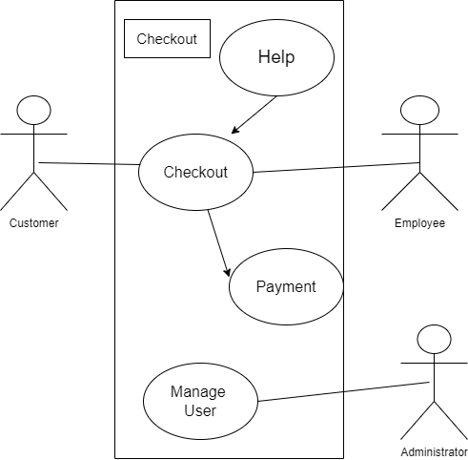

3.6.2 Developer’s Side:- Admin Side

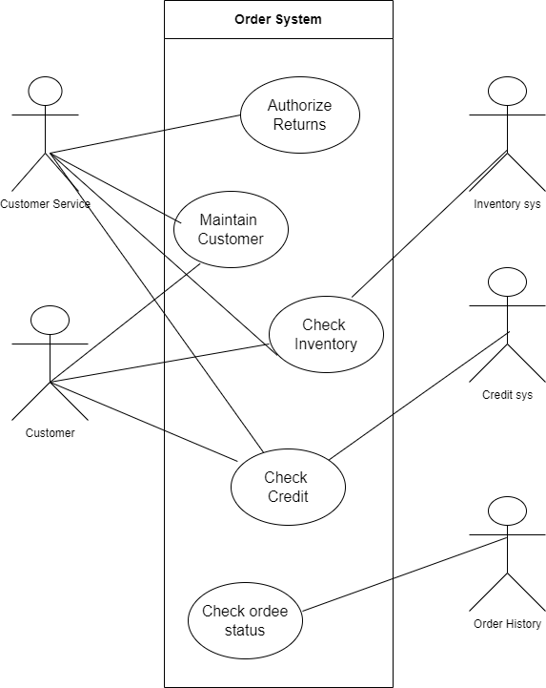

3.7 Use Case Diagram:-

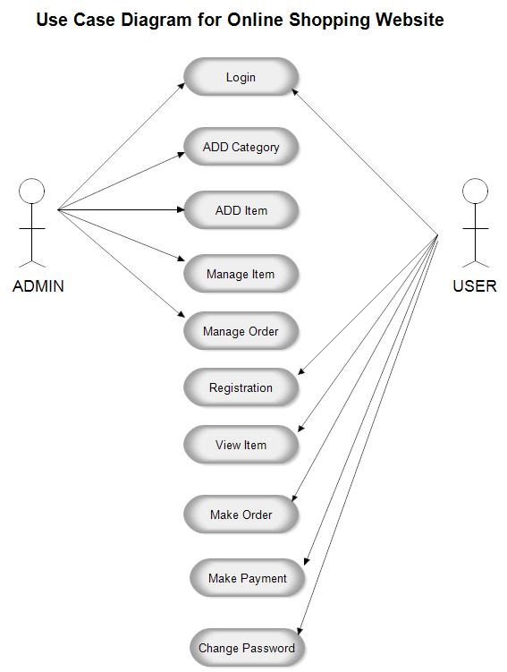

4. Design

4.1 Use case Scenarios:-

| **Main Scenarios** | **Serial No** | **Steps** |
| --- | --- | --- |
| Admin | 1 | Enter username Enter Password |
|  | 2 | Validate Username and Password |
|  | 3 | Allow access to System |
| Users | 4 | Invalid Username System shows an error message |
|  | 5 | Invalid Password System shows an error message |
|  | 6 | Invalid Password for 4 times Application closed |

4.2 Data Flow Diagram

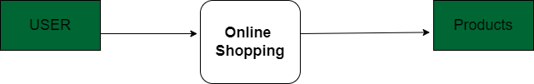

Figure 4.2.1:Context Level Diagram

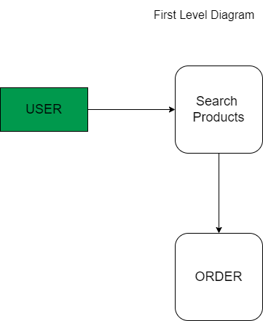

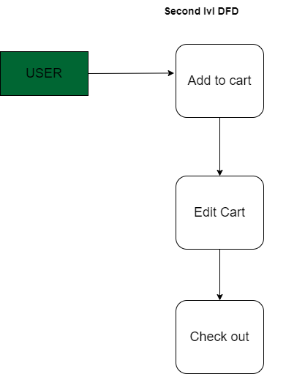

4.2.1 Class Diagram

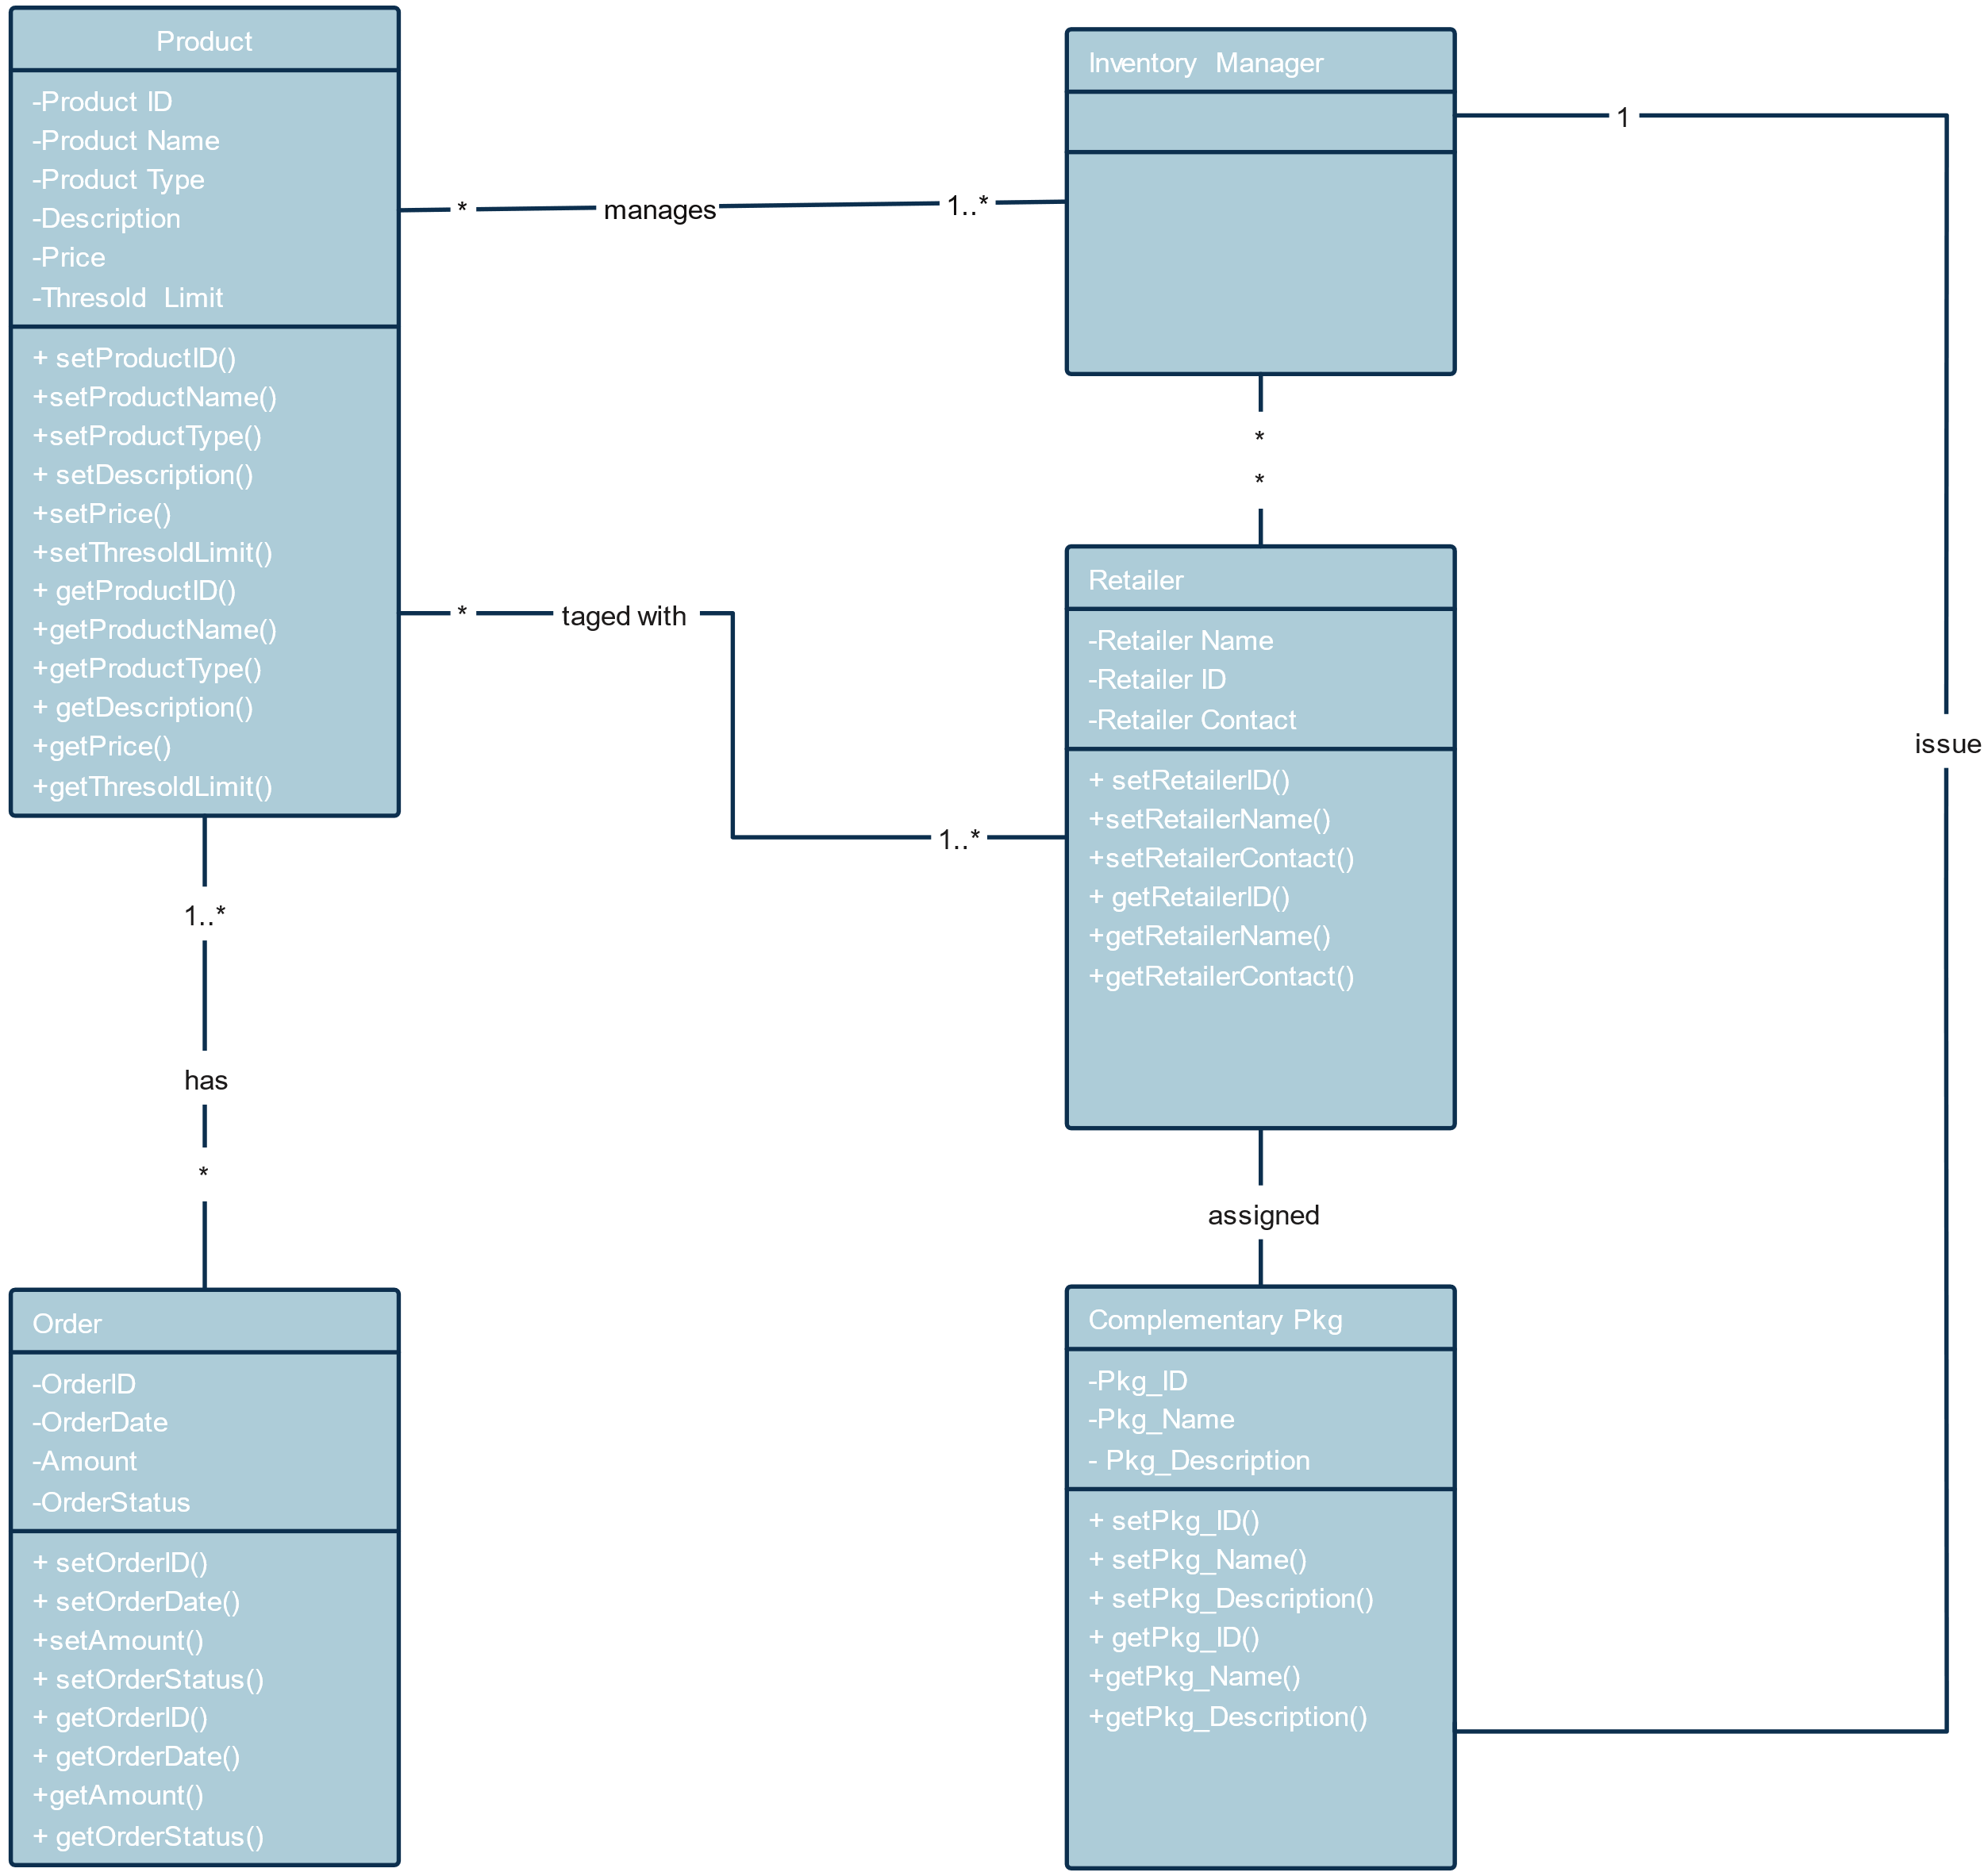

4.2.2 Entity Relationship Diagram:-

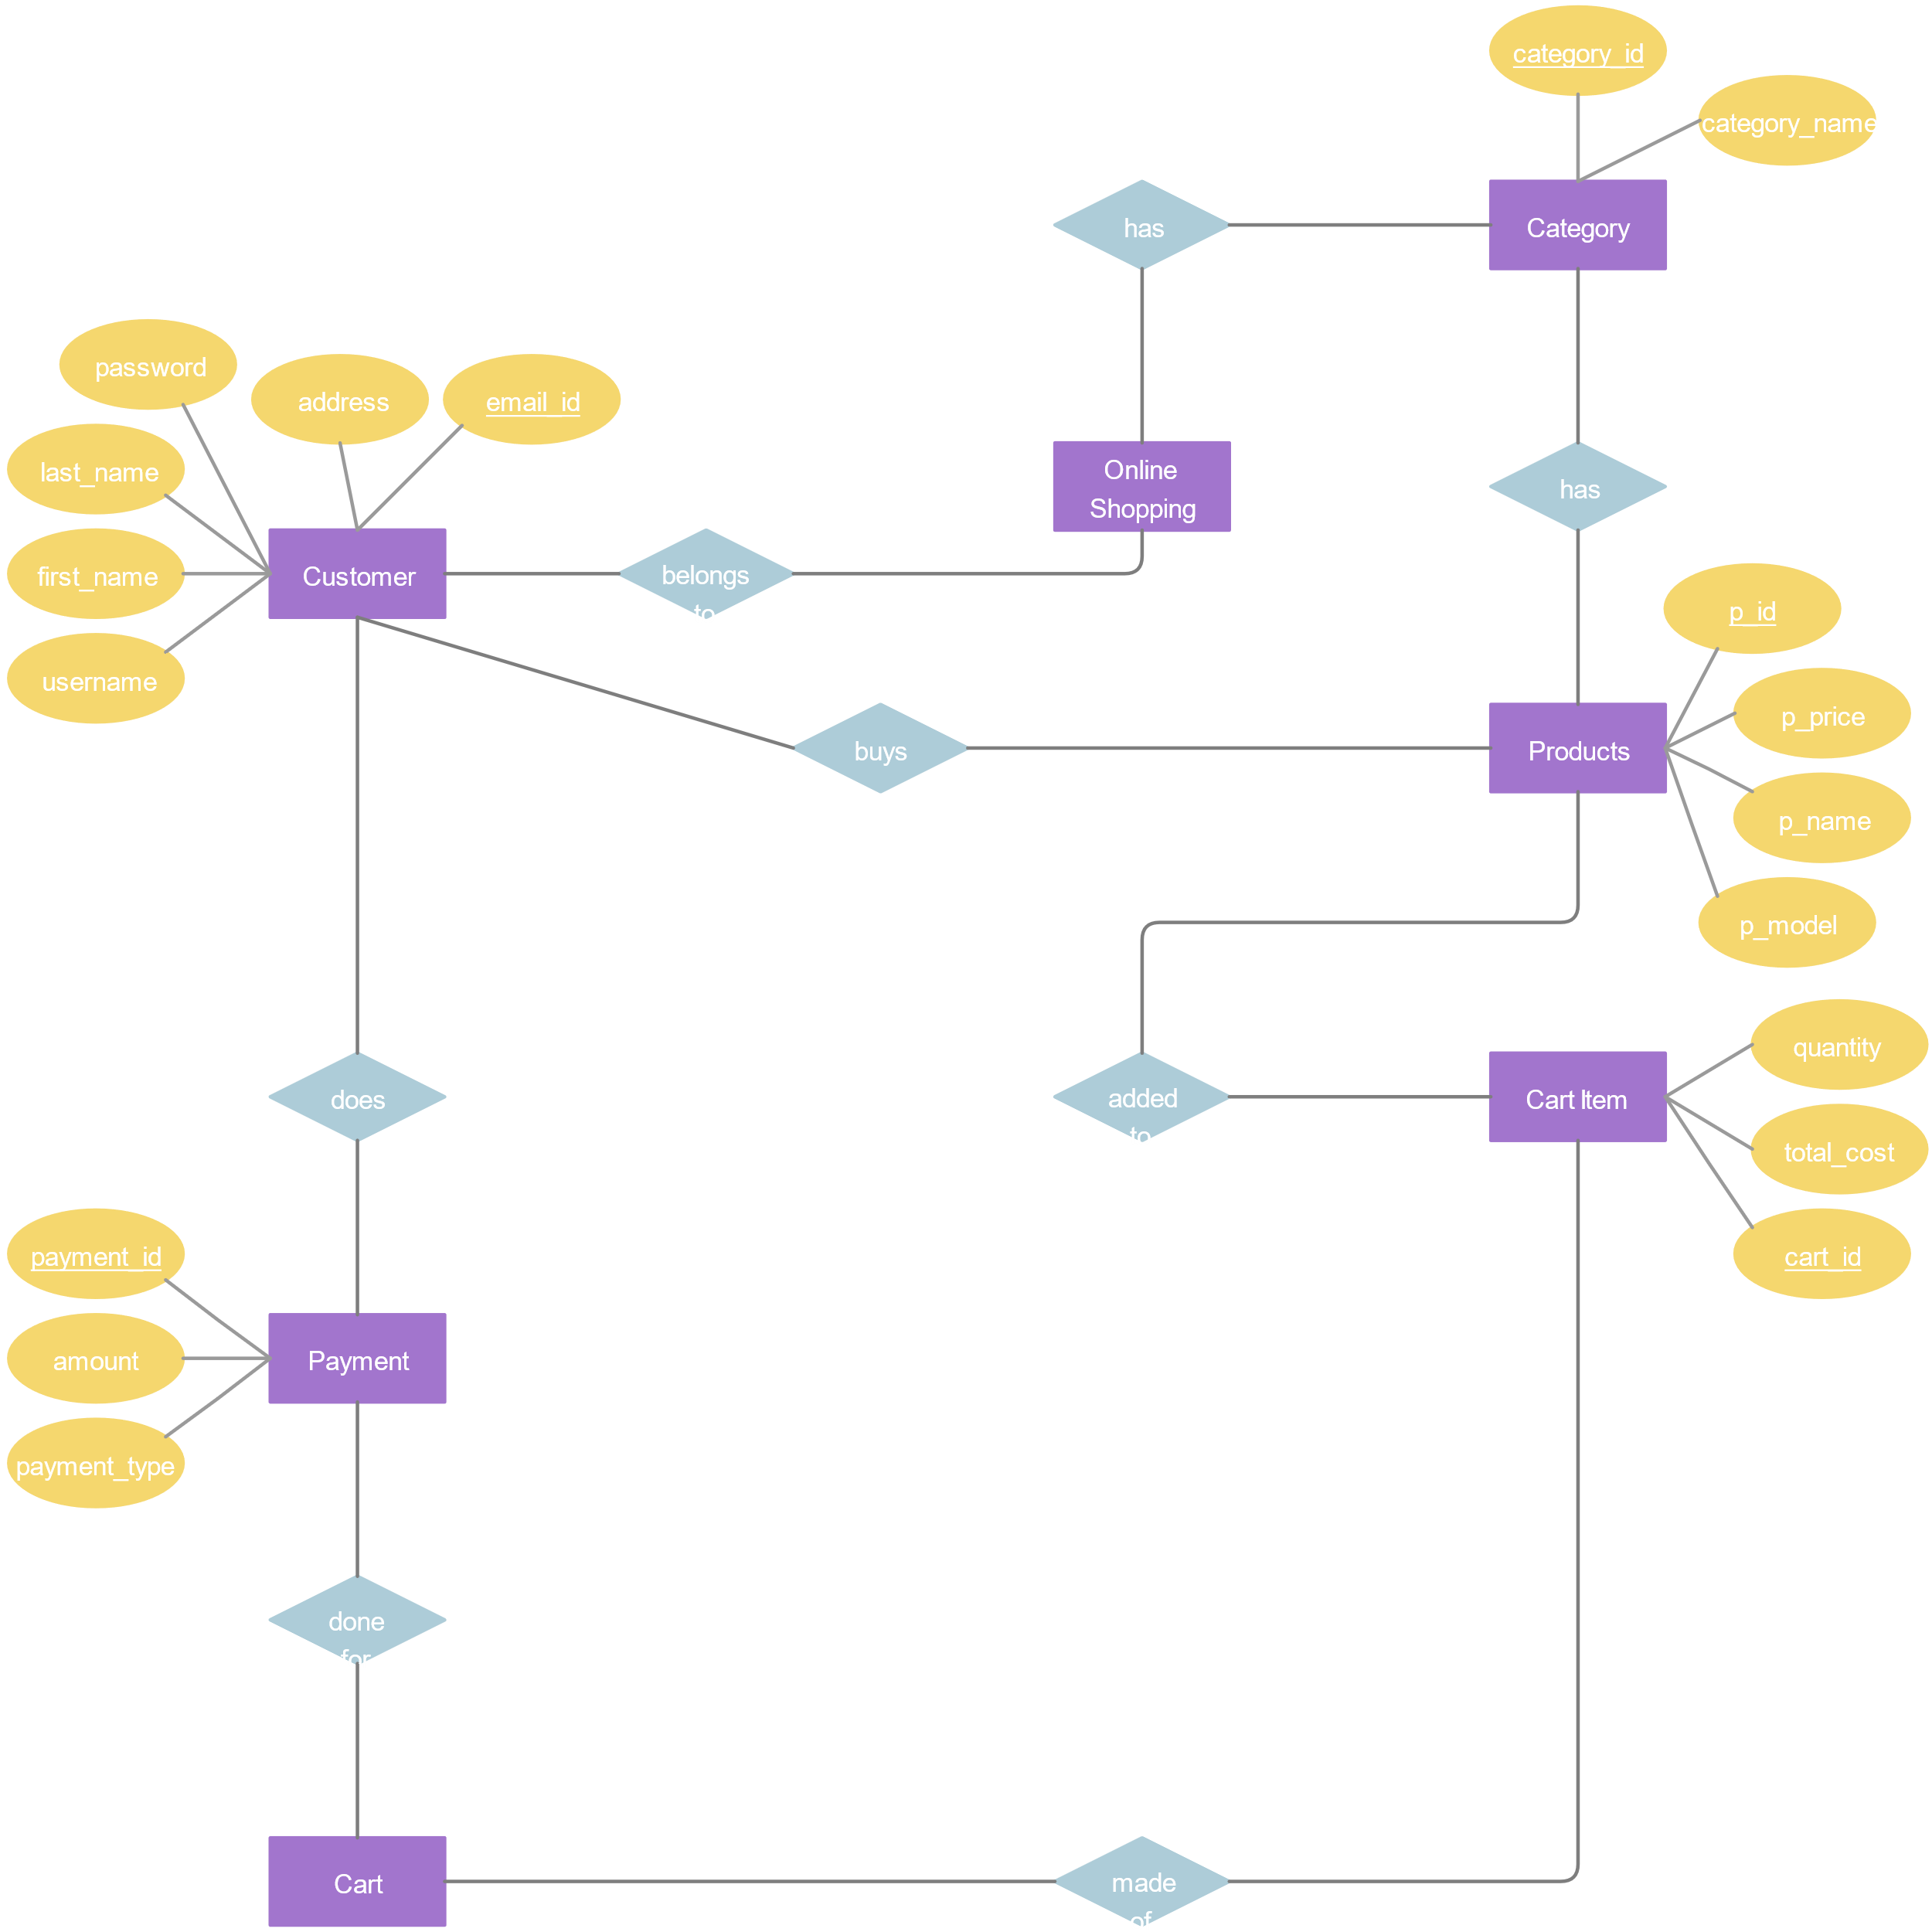

4.3 Data Dictionary

|  |  |  |  |
| --- | --- | --- | --- |
| Table: Products |  |  |  |
|  |  |  |  |
| Field Name | DataType | Length | Description |
| ProductID | Int | 10 | Unique identifier for the product. |
| SKU | Varchar | 20 | Stock Keeping Unit for the product. |
| ProductName | Varchar | 100 | Name of the product. |
| CategoryID | Int | 10 | Foreign key to Categories table. |
| SupplierID | Int | 10 | Foreign key to Suppliers table. |
| UnitPrice | Decimal | 10,2 | Price per unit of the product. |
| UnitsInStock | Int | 10 | Number of units currently in stock. |
| ReorderLevel | Int | 10 | Minimum units before reordering. |
| Discontinued | Boolean | 1 | Indicates if the product is discontinued. |

|  |  |  |  |
| --- | --- | --- | --- |
| Table: Categories |  |  |  |
|  |  |  |  |
| Field Name | DataType | Length | Description |
| CategoryID | Int | 10 | Unique identifier for the category. |
| CategoryName | Varchar | 50 | Name of the category. |
| Description | Text |  | Description of the category. |

|  |  |  |  |
| --- | --- | --- | --- |
| Table: Suppliers |  |  |  |
|  |  |  |  |
| Field Name | Data Type | Length | Description |
| SupplierID | Int | 10 | Unique identifier for the supplier. |
| CompanyName | Varchar | 100 | Name of the supplier company. |
| ContactName | Varchar | 50 | Name of the contact person. |
| Phone | Varchar | 20 | Contact phone number. |
| Email | Varchar | 100 | Contact email address. |
| Address | Text |  | Supplier's address. |

|  |  |  |  |
| --- | --- | --- | --- |
| Table: Orders |  |  |  |
| Field Name | Data Type | Length | Description |
| OrderID | Int | 10 | Unique identifier for the order. |
| OrderDate | Date |  | Date when the order was placed. |
| ProductID | Int | 10 | Foreign key to Products table. |
| Quantity | Int | 10 | Number of units ordered. |
| TotalCost | Decimal | 10,2 | Total cost of the order. |

5. Implementation

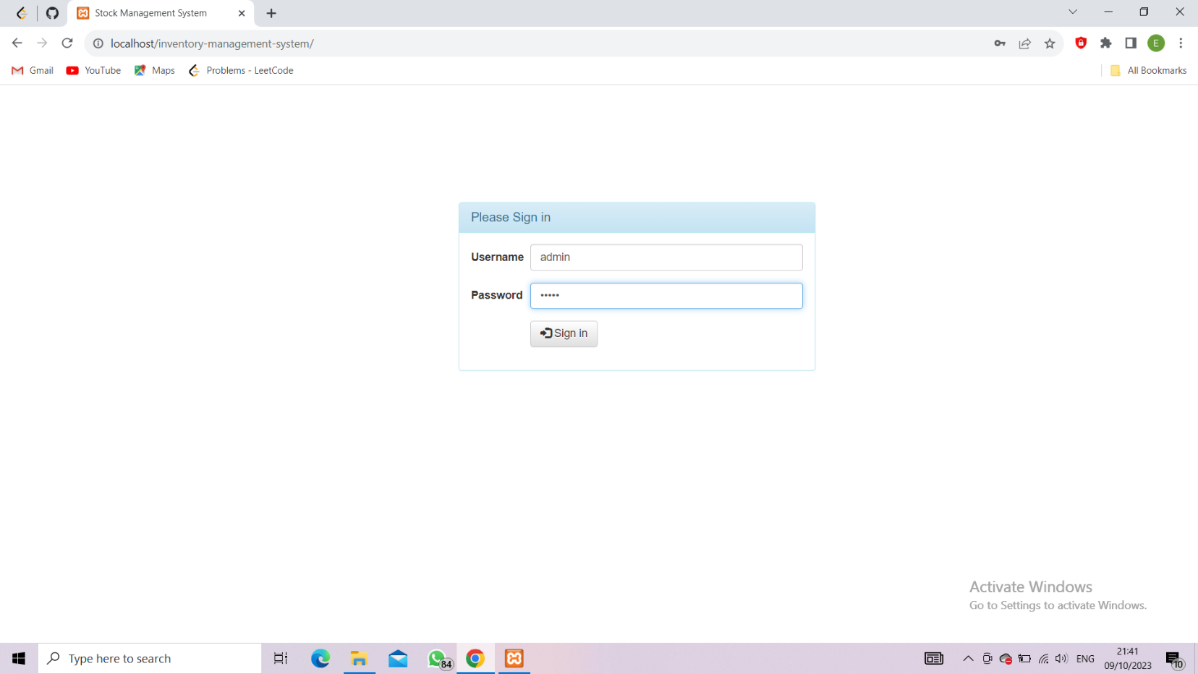

5.1 Login Page

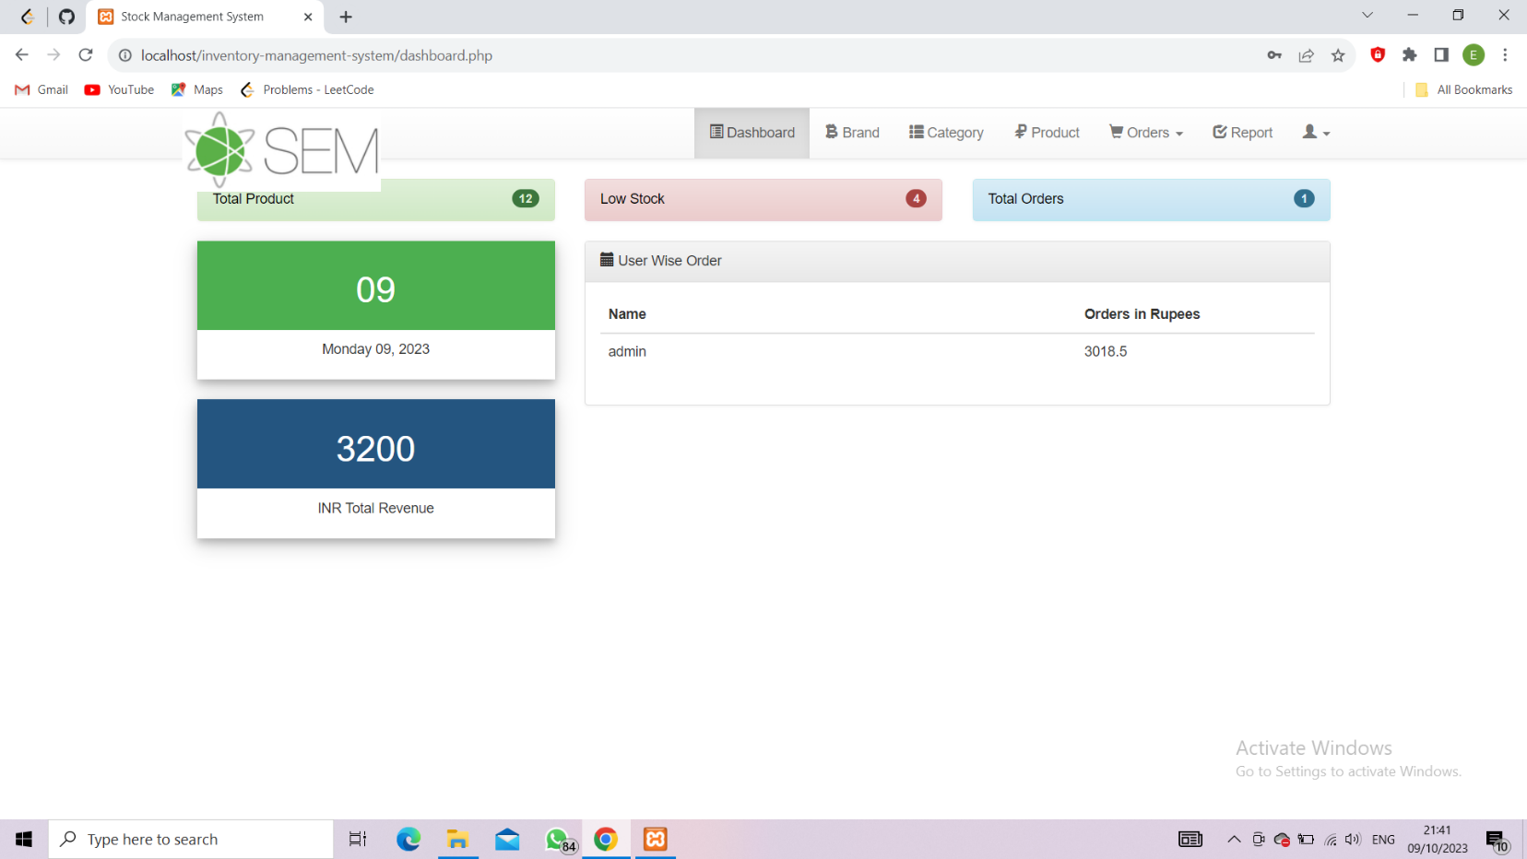

5.3 Main Form Page

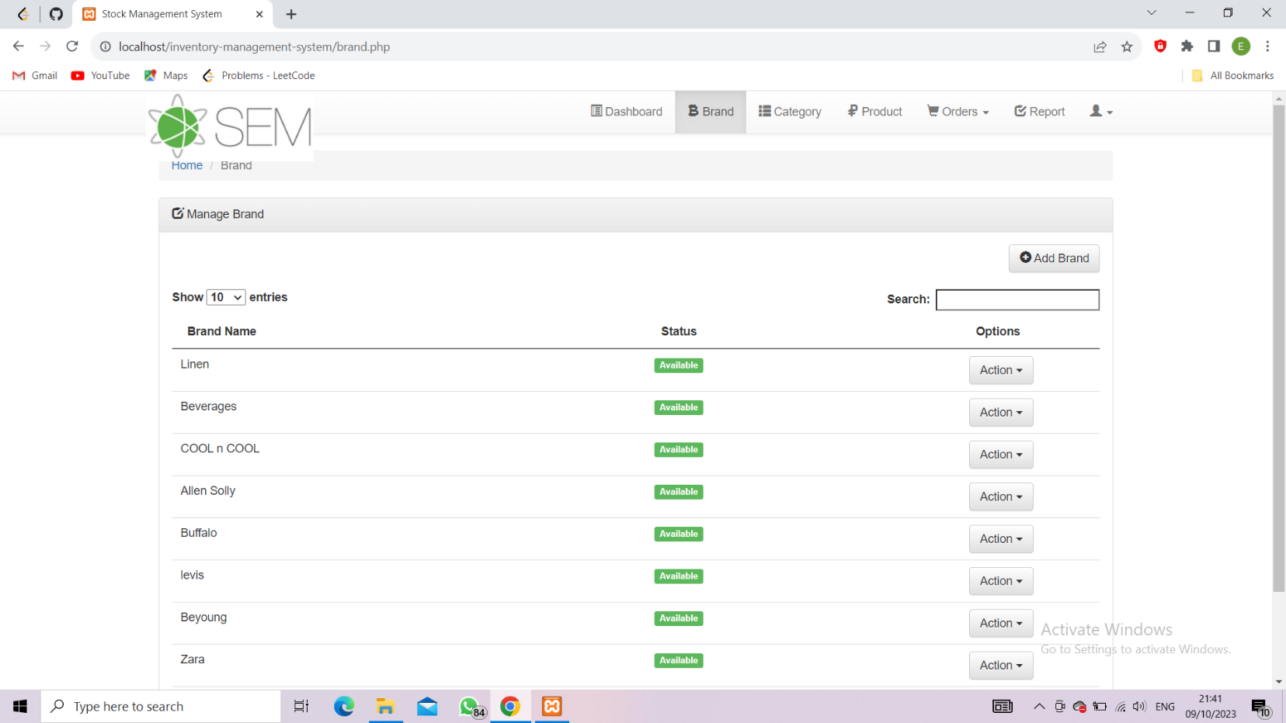

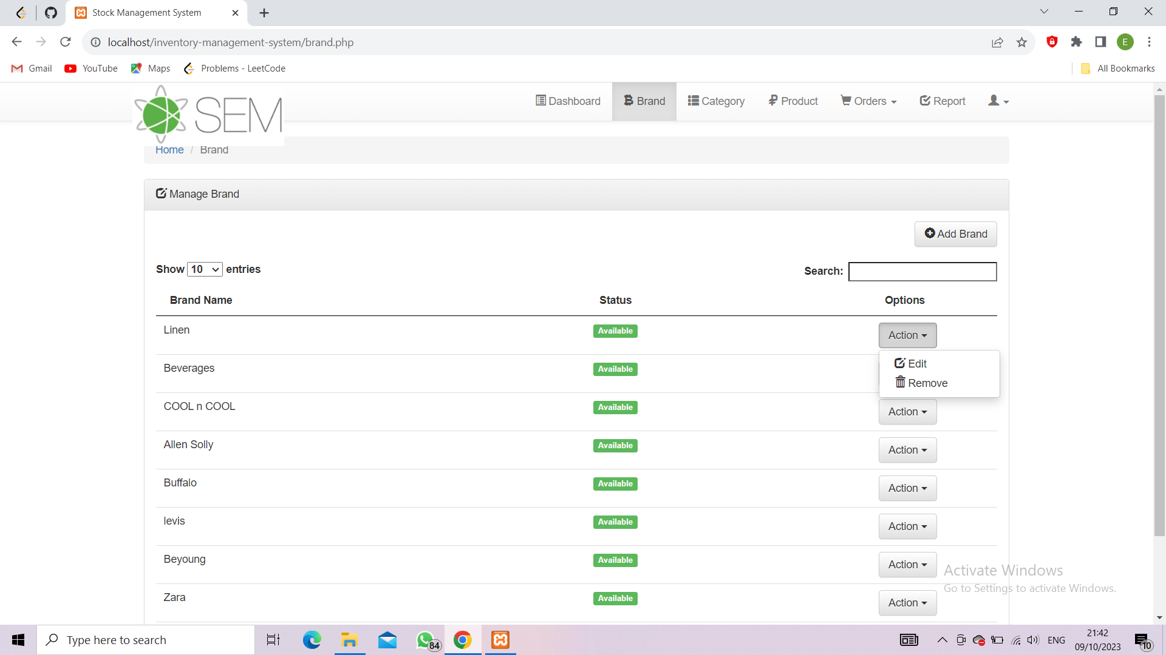

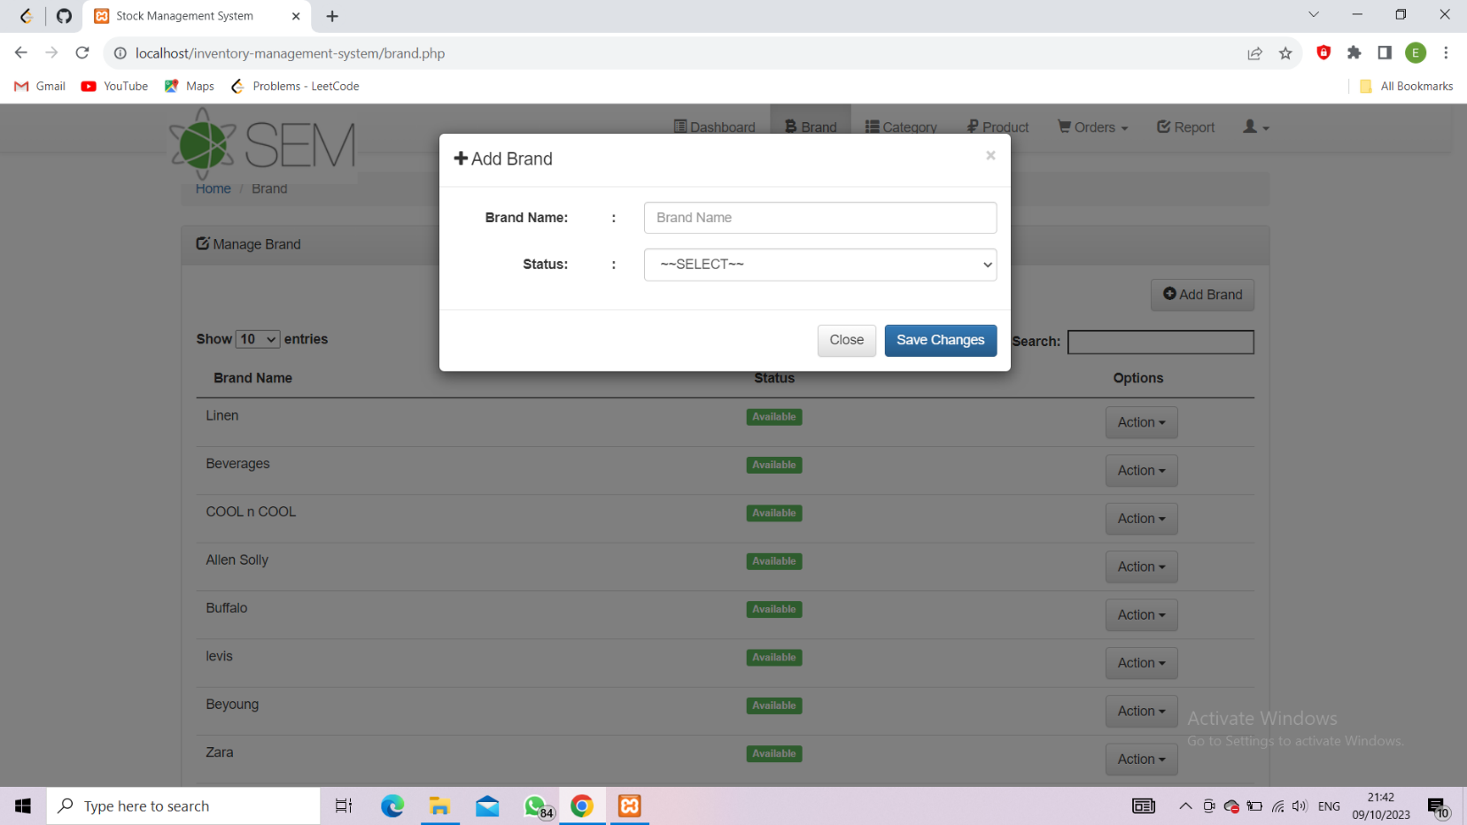

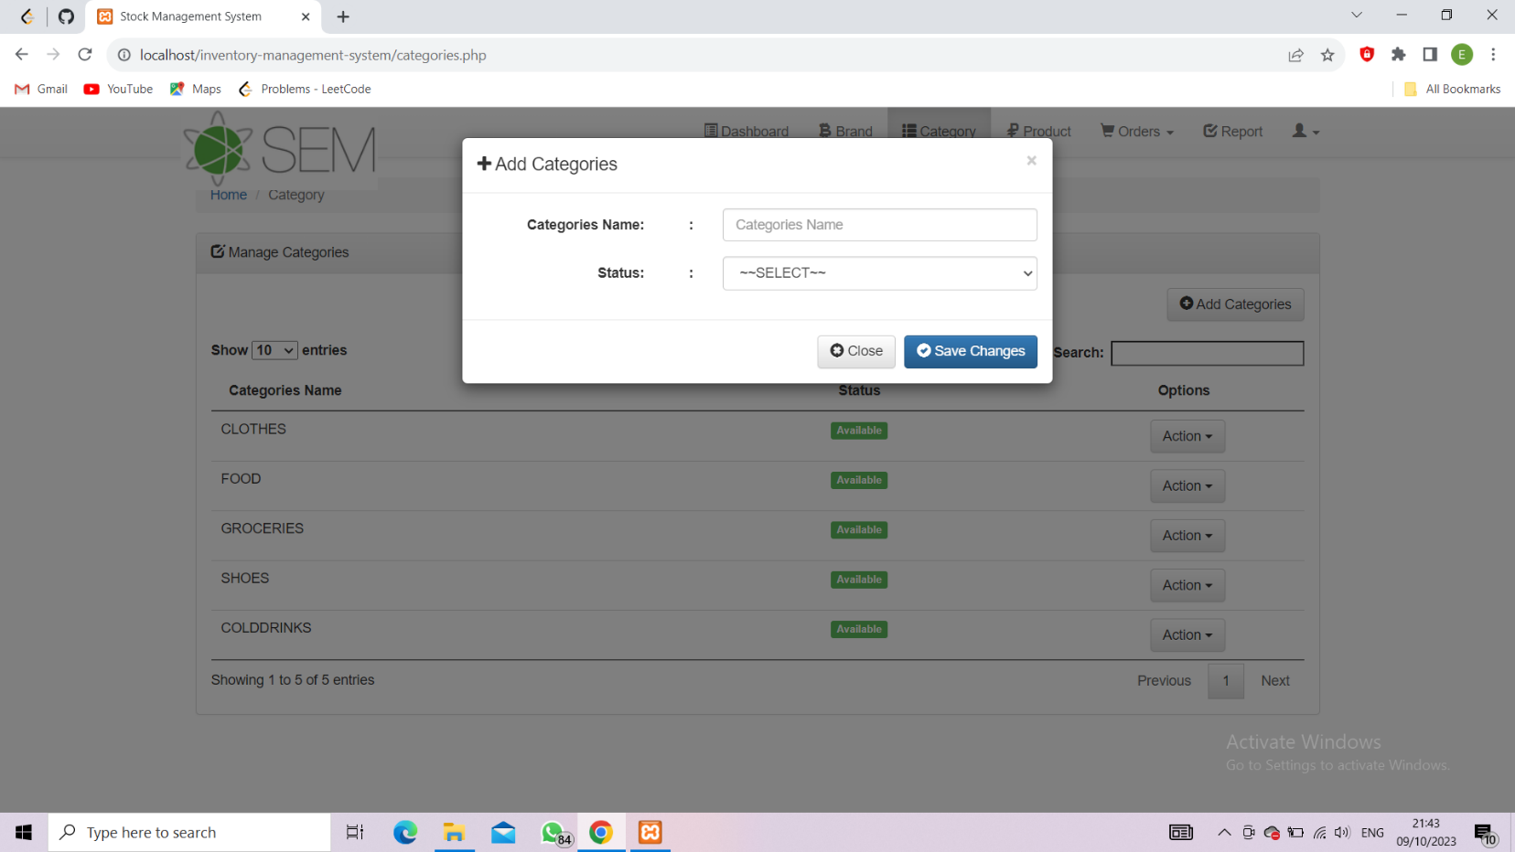

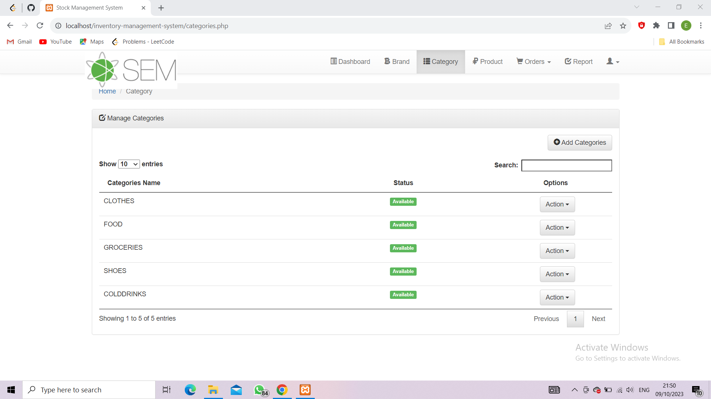

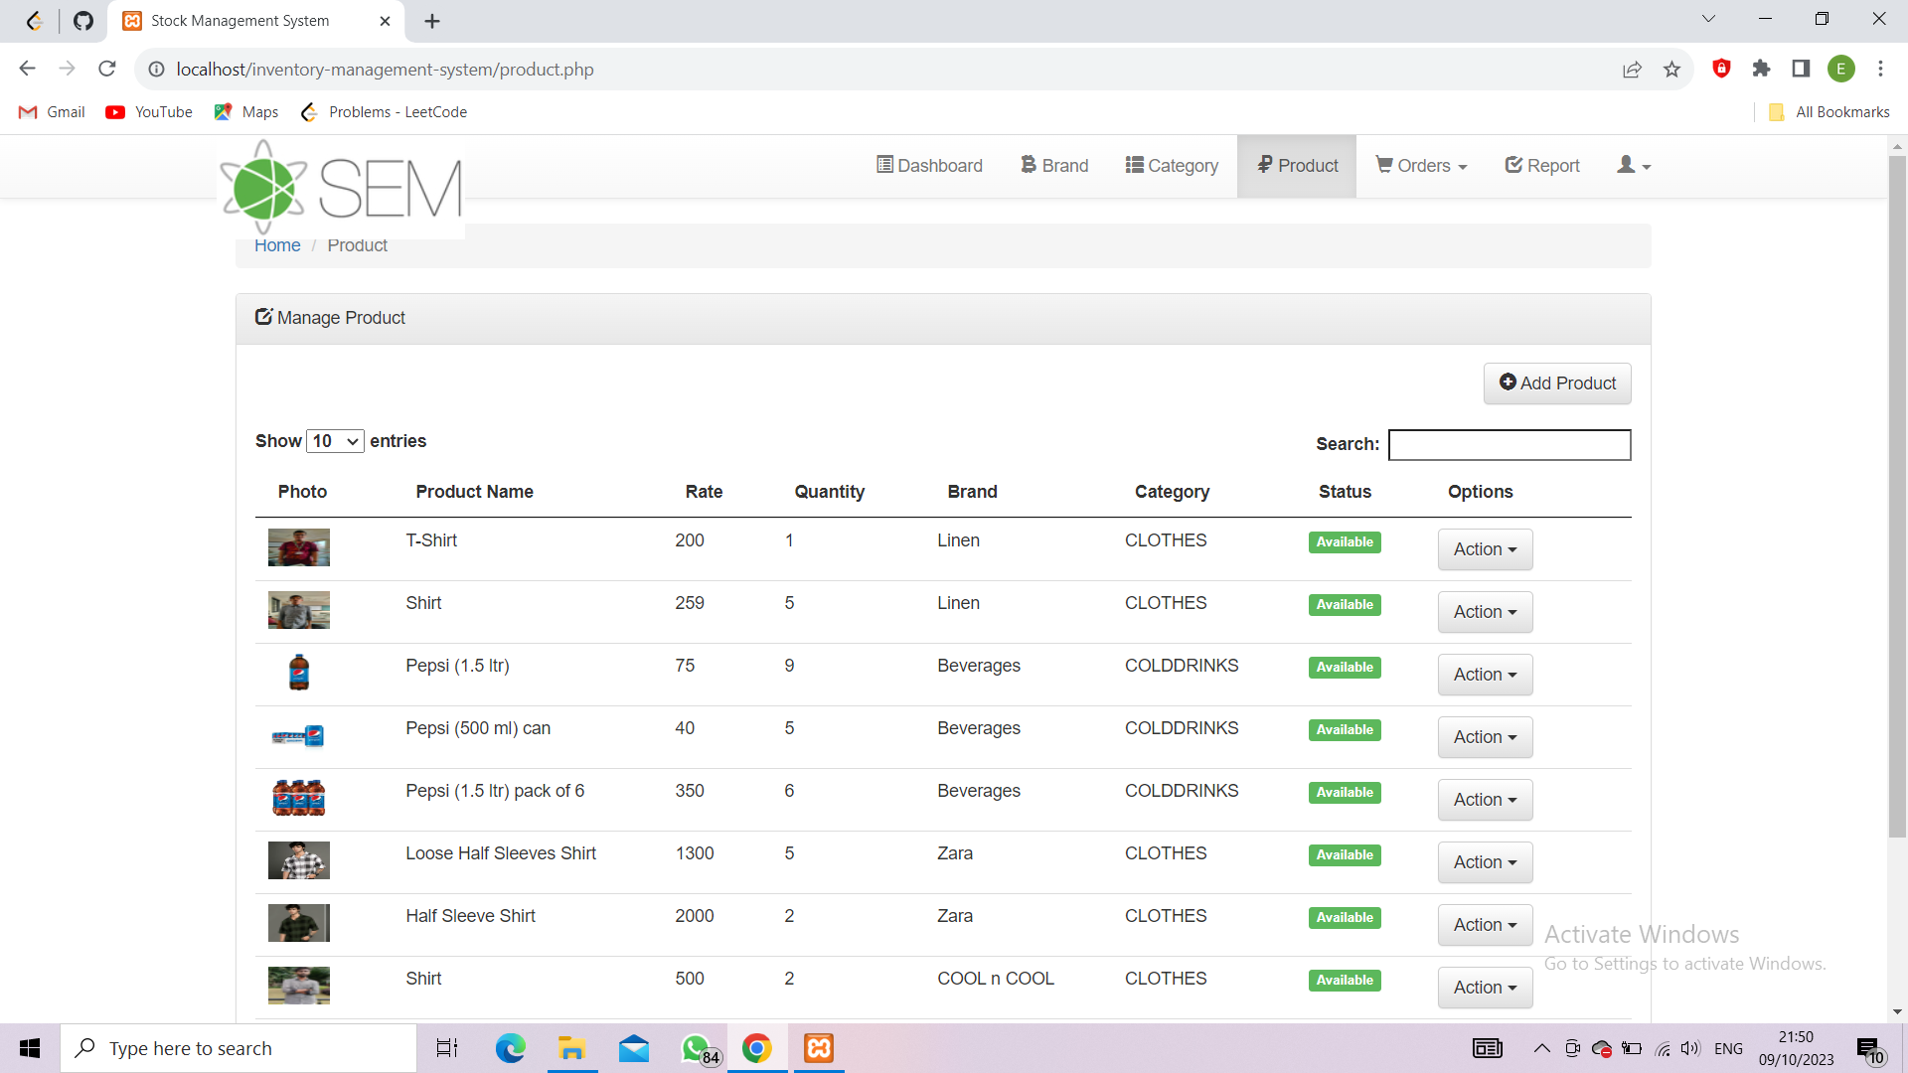

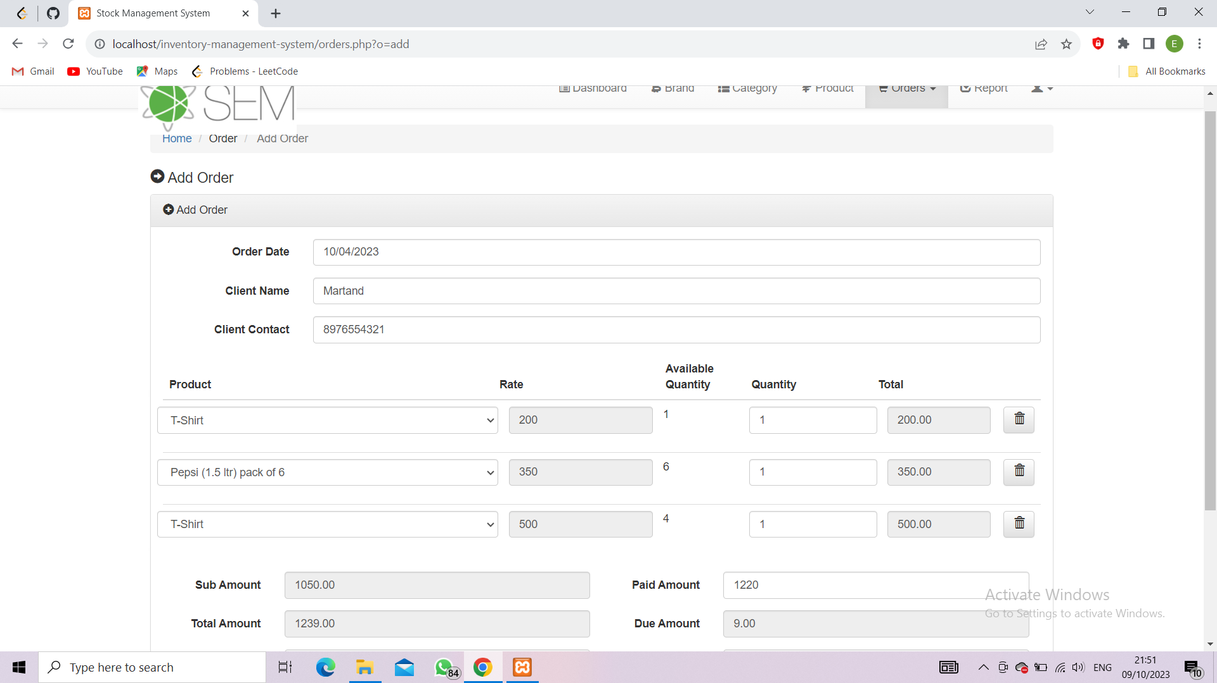

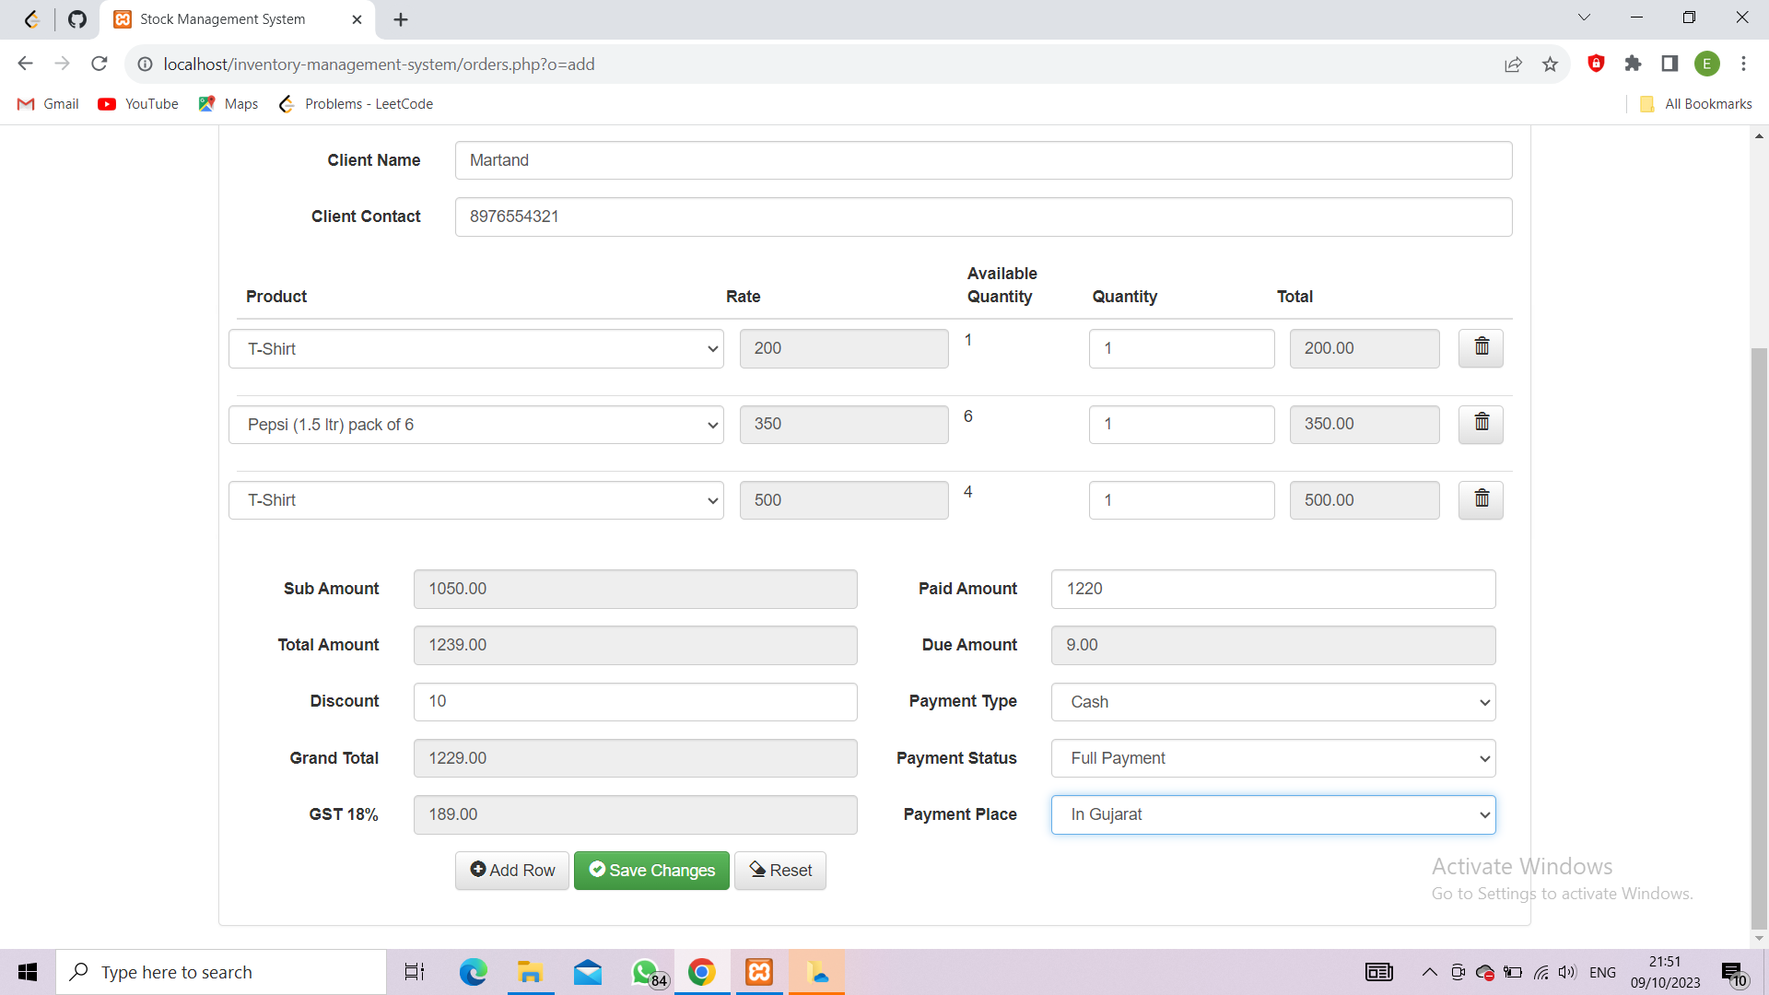

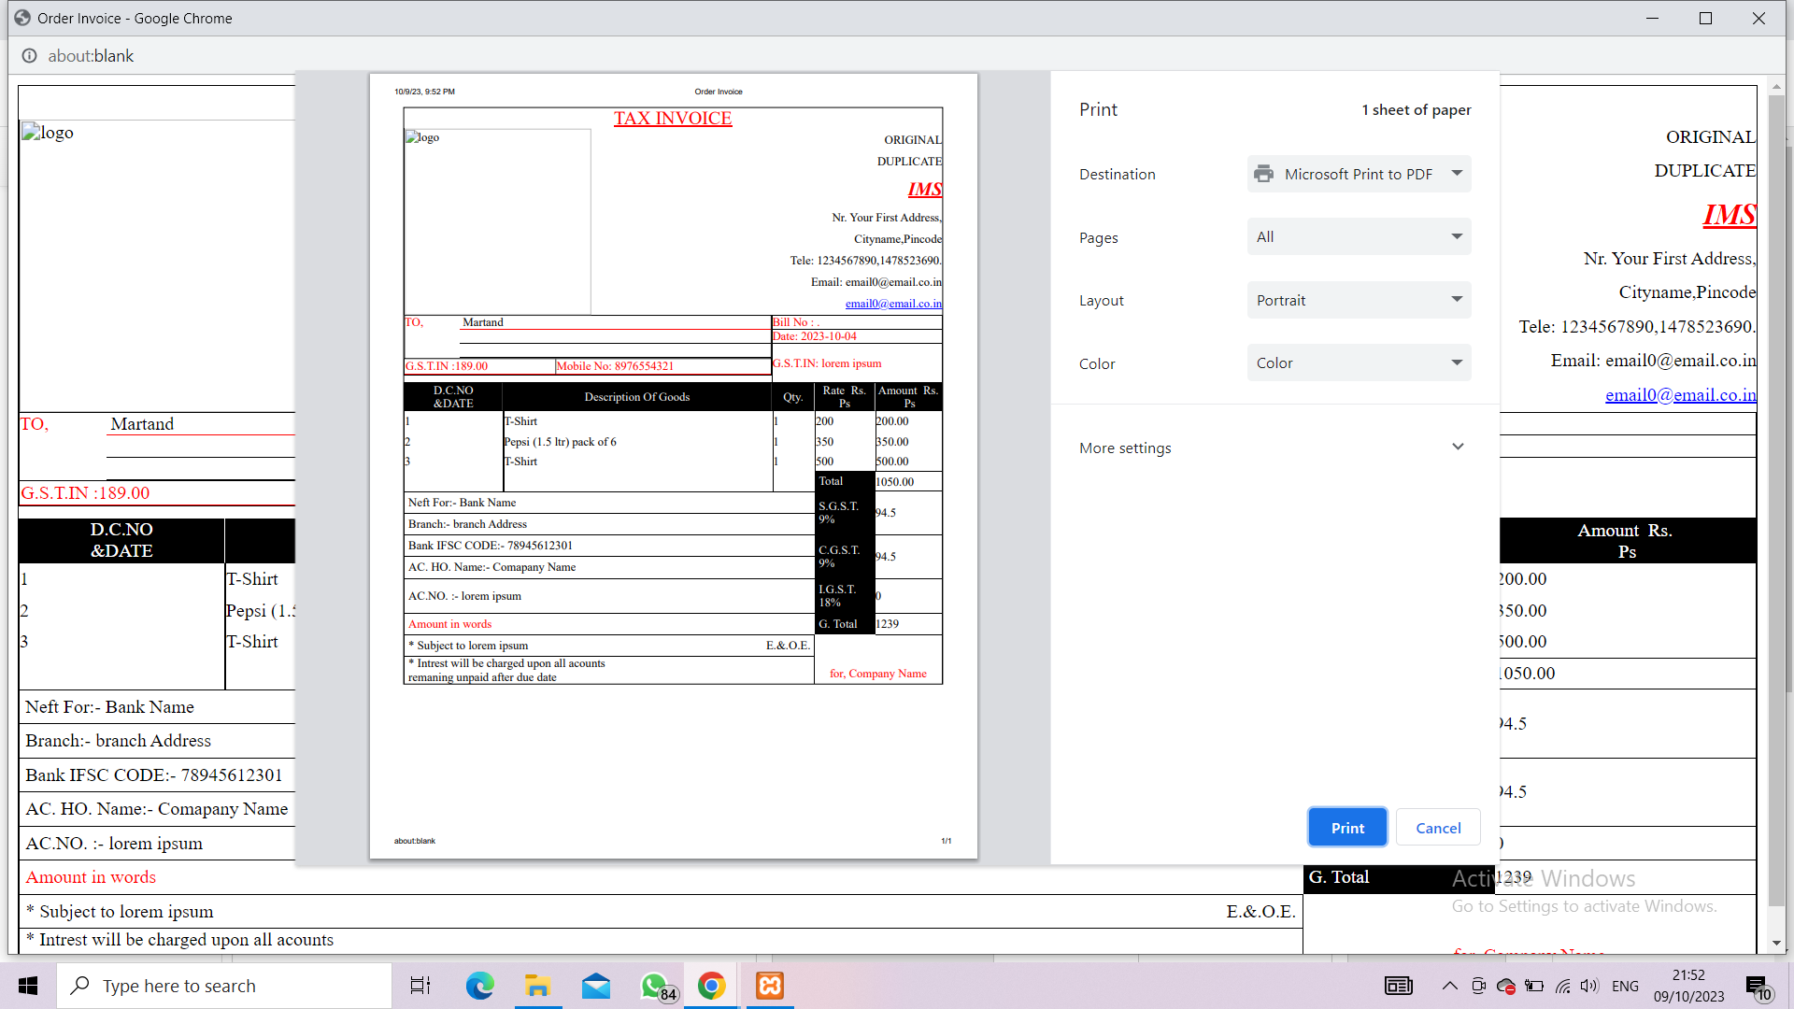

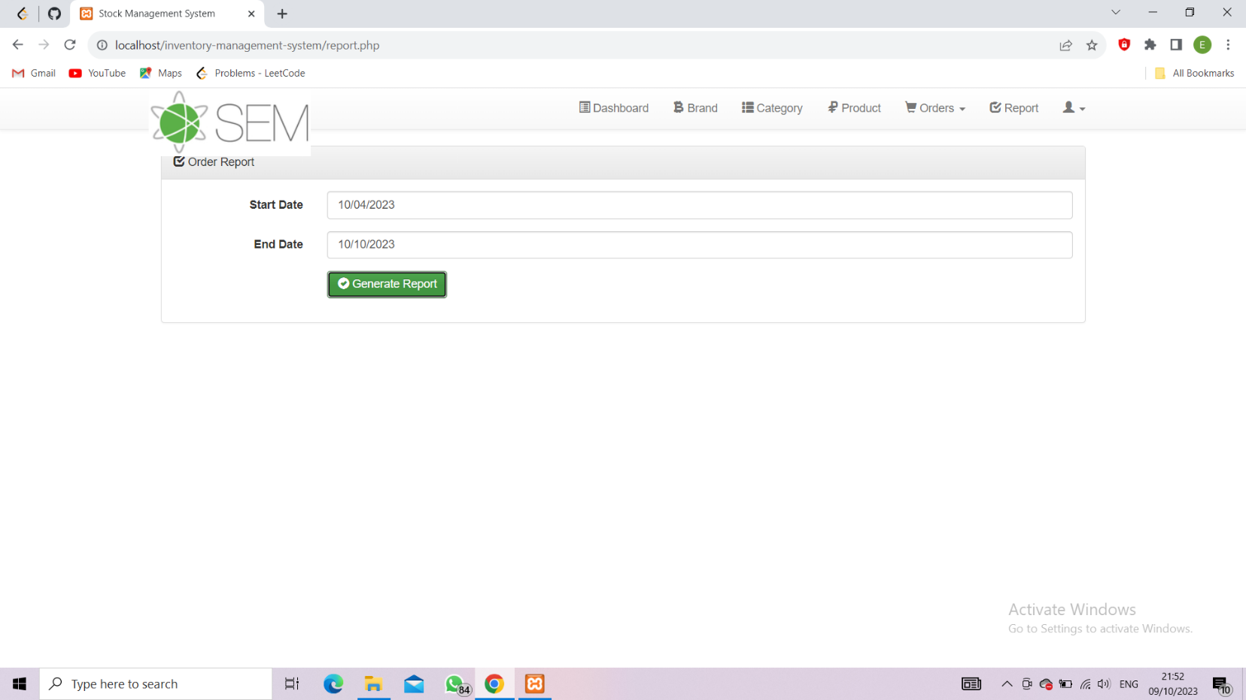

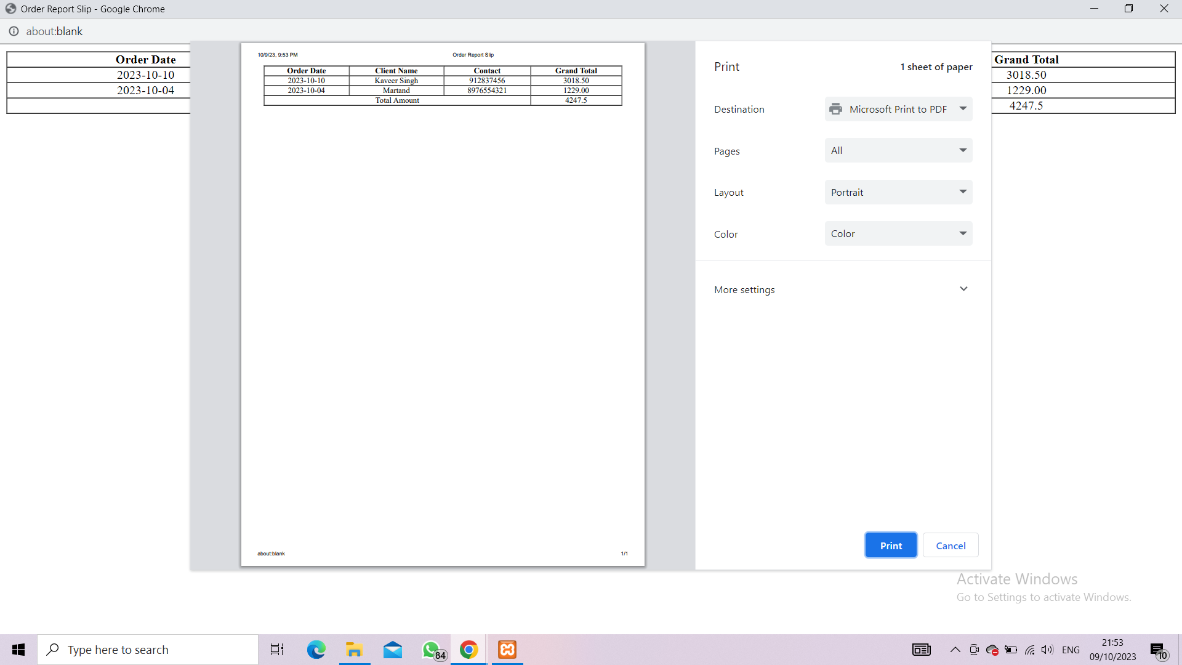

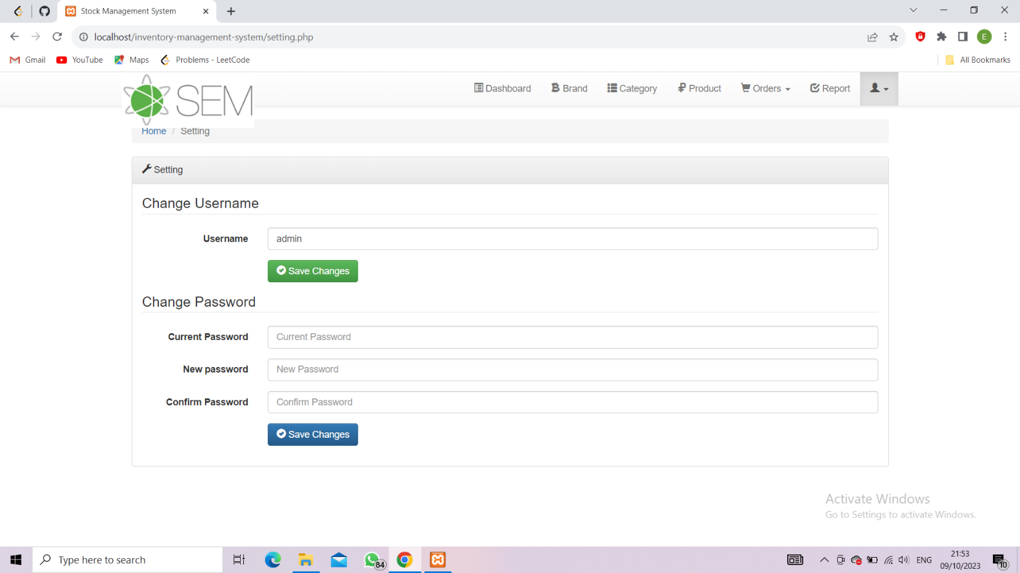

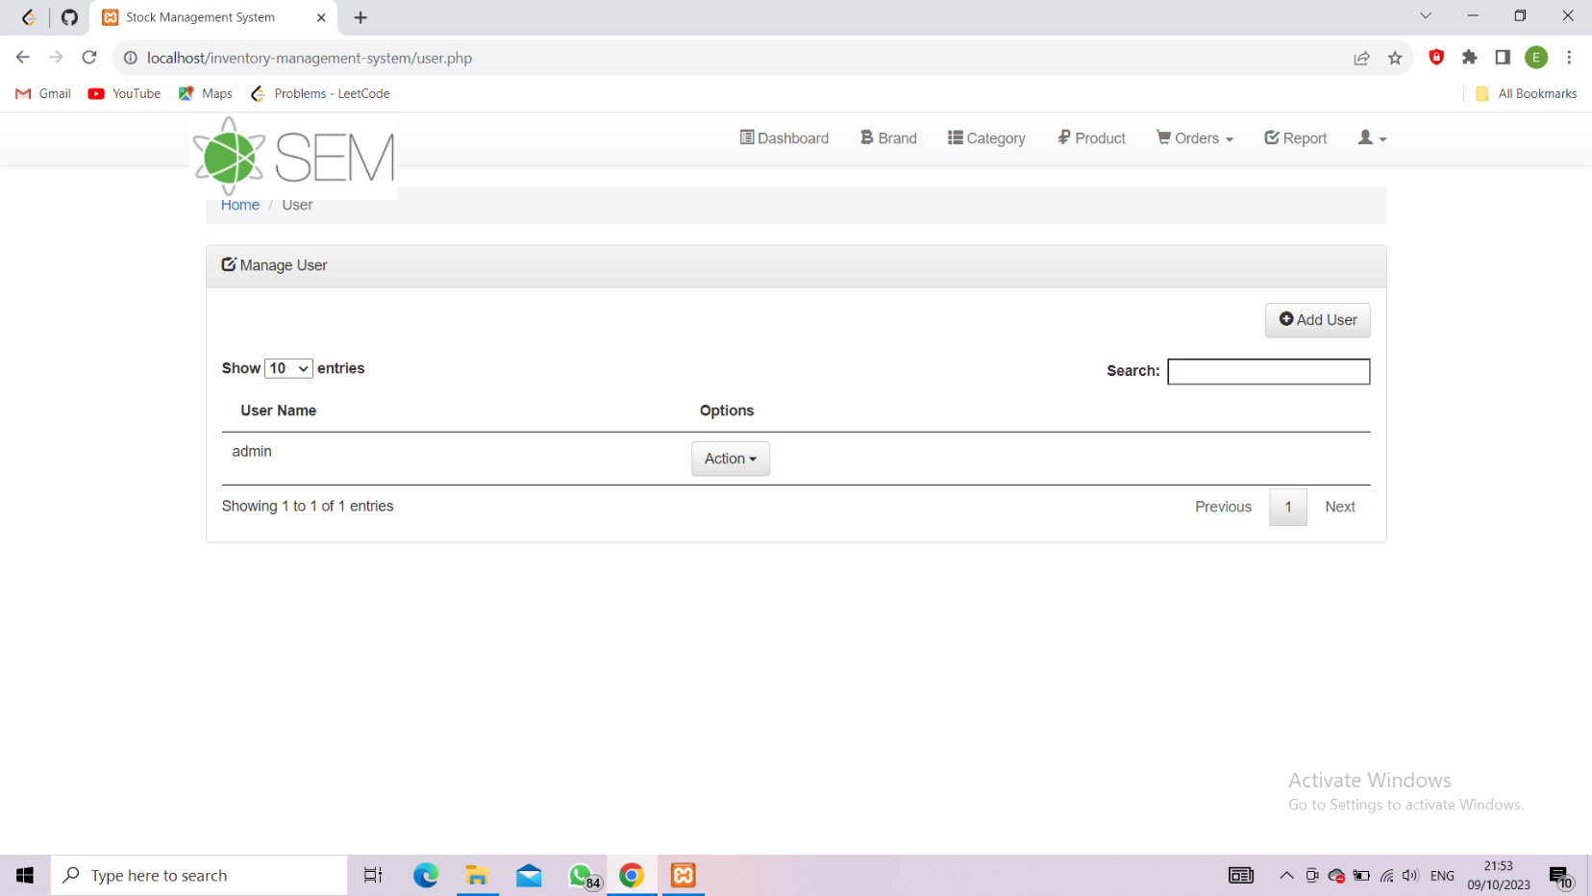

6. Testing

6.1 - Creating a comprehensive test strategy for an inventory management system is crucial to ensure the software performs accurately and reliably. Below, I outline the key elements of a test strategy, including the preparation of a test plan, identification of testing methods/techniques, and selection of testing tools.

Test Strategy for Inventory Management System:

Scope and Objectives:

Define the scope of testing, including the specific modules and functionalities to be tested.

Clearly state the objectives, such as ensuring accurate inventory tracking, efficient order management, and user-friendliness.

Test Levels:

Identify the test levels, including unit testing, integration testing, system testing, and user acceptance testing (UAT).

Test Environment:

Specify the hardware, software, and network environment required for testing.

Ensure that the test environment mirrors the production environment as closely as possible.

Test Data:

Prepare realistic and diverse test data, including different product categories, order types, and inventory scenarios.

Ensure the data includes edge cases and potential exceptions.

Test Plan:

Develop a detailed test plan that outlines the test cases, test scripts, and test scenarios.

Define the entry and exit criteria for each test level.

Specify the schedule, resources, and responsibilities.

Testing Methods and Techniques:

Choose appropriate testing methods and techniques, including:

Functional Testing: Ensure each function works as intended.

Performance Testing: Evaluate system performance under various loads.

Security Testing: Test for vulnerabilities and data security.

Usability Testing: Assess the user-friendliness of the interface.

Regression Testing: Ensure new updates don't break existing features.

User Acceptance Testing (UAT): Validate the system with end-users.

Exploratory Testing: Testers explore the system with minimal pre-defined test cases.

Consider both manual and automated testing methods.

Testing Tools:

Select appropriate testing tools based on the testing methods:

For Functional Testing, tools like Selenium, Appium, or TestComplete for automated testing can be useful.

For Performance Testing, tools like Apache JMeter, LoadRunner, or Gatling.

For Security Testing, tools like OWASP ZAP, Burp Suite, or Nessus.

For Usability Testing, consider user experience testing tools like UsabilityHub.

For Regression Testing, tools that support test automation and continuous integration (e.g., Jenkins).

Test Data Management:

Ensure that test data is managed effectively, including data generation, data masking for privacy, and data backup and recovery.

Reporting and Defect Management:

Define the reporting format for test results.

Establish a process for logging and tracking defects, including severity, priority, and resolution status.

Review and Approval:

Include a step for review and approval of the test strategy by stakeholders and the quality assurance team.

Documentation and Compliance:

Ensure that all testing activities are well-documented, and the testing process complies with relevant industry standards and regulations.

Test Execution and Monitoring:

Execute test cases according to the test plan.

Continuously monitor and report on the progress and results of testing activities.

Test Sign-off:

Obtain sign-off from relevant stakeholders when testing is complete and the system is deemed ready for deployment.

Continuous Improvement:

Implement a process for capturing lessons learned and making improvements for future releases and projects.

By following this test strategy, you can systematically plan and execute testing for your inventory management system to ensure it meets the required quality standards and fulfills its business objectives.

|  |  |  |  |  |
| --- | --- | --- | --- | --- |
| Test Case Format: |  |  |  |  |
|  |  |  |  |  |
| Test Case ID | Test Case Description | Test Steps | Expected Result | Pass/Fail |
| TC001 | Verify Login Function | 1. Open the login page | Login page is displayed | Pass |
|  |  | 2. Enter valid username and password | User is logged in successfully | Pass |
| TC002 | Add New Product | 1. Navigate to the "Add Product" page | Add Product page is displayed | Pass |
|  |  | 2. Fill in product details | Product is added, success notification | Pass |
| TC003 | Search for Product | 1. Enter product name in search bar | Matching products are displayed | Pass |
|  |  | 2. Click on a product from the list | Product details are shown | Pass |
| TC004 | Update Product | 1. Navigate to the product details | Product details page is displayed | Pass |
|  |  | 2. Edit product information | Product information is updated | Pass |
| TC005 | Delete Product | 1. Navigate to the product details | Product is deleted, success notification | Pass |
|  |  | 2. Click "Delete" button | Product details page is displayed | Pass |
| TC006 | Place an Order | 1. Navigate to the "Place Order" page | Order is placed, success notification | Pass |
|  |  | 2. Select a product and quantity | Place Order page is displayed | Pass |
| TC007 | Check Stock Levels | 1. Navigate to the "Stock Levels" page | Stock levels are accurate | Pass |
|  |  | 2. Review stock information | Stock Levels page is displayed | Pass |
|  |  |  |  |  |

7.Bibliography

7.1-Books:

Chopra, Sunil, and Peter Meindl. "Supply Chain Management: Strategy, Planning, and Operation." Pearson, 2018.

Silver, Edward A., and David F. Pyke. "Inventory Management and Production Planning and Scheduling." CRC Press, 2018.

Waters, Donald. "Inventory Control and Management." John Wiley & Sons, 2011.

Simchi-Levi, David, Philip Kaminsky, and Edith Simchi-Levi. "Designing and Managing the Supply Chain: Concepts, Strategies, and Case Studies." McGraw-Hill Education, 2017.

Jacobs, F. Robert, and Richard B. Chase. "Operations and Supply Chain Management." McGraw-Hill Education, 2016.

Academic Articles:

Goyal, Suresh K. "Recent trends in modeling of deteriorating inventory." European Journal of Operational Research 134, no. 1 (2001): 1-16.

Silver, Edward A., and Rein Peterson. "Decision systems for inventory management and production planning." John Wiley & Sons, 1998.

Nahmias, Steven. "Production and operations analysis." Irwin/McGraw-Hill, 2009.

Cooper, Martha C., and Lisa M. Ellram. "Characteristics of supply chain management and the implications for purchasing and logistics strategy." The International Journal of Logistics Management 8, no. 1 (1997): 1-14.

Cachon, Gérard P., and Christian Terwiesch. "Matching supply with demand: An introduction to operations management." McGraw-Hill, 2019.

7.2 - Websites:

Investopedia - Inventory Management: Investopedia offers in-depth articles and tutorials on inventory management principles and techniques.

Website: https://www.investopedia.com/terms/i/inventory-management.asp

The Balance Small Business - Inventory Management: This website provides practical advice and articles on inventory management for small businesses.

Website: https://www.thebalancesmb.com/inventory-management-4160838

Smartsheet - Inventory Management Templates and Resources: Smartsheet provides templates and resources to help you manage inventory effectively.

Website: https://www.smartsheet.com/inventory-management

TradeGecko Blog: TradeGecko's blog covers various aspects of inventory management, with a focus on e-commerce and small businesses.

Website: https://www.tradegecko.com/blog

Supply Chain 24/7: This website offers articles and resources related to supply chain and inventory management.

Website: https://www.supplychain247.com/

YouTube Channels:

APICS: APICS, the Association for Supply Chain Management, has a YouTube channel with videos on various supply chain topics, including inventory management.

YouTube Channel: https://www.youtube.com/user/APICSTV

QuickBooks: QuickBooks offers tutorials and webinars on inventory management for small businesses.

YouTube Channel: https://www.youtube.com/user/Quickbooks

InventoryOps: InventoryOps provides video tutorials and explanations on various inventory management concepts.

YouTube Channel: https://www.youtube.com/user/InventoryOps

Logility, Inc.: Logility's YouTube channel offers insights into supply chain and inventory optimization.

YouTube Channel: https://www.youtube.com/user/LogilityInc

Supply Chain Academy: This channel covers various aspects of supply chain management, including inventory management.

YouTube Channel: <https://www.youtube.com/channel/UCItbFfGWosf63z-gUFJgh9w>

1. **About Department of MCA& M.Sc. IT**

**PARUL University**

Parul University is a legitimate university established under Gujarat Private University Act 2009, after legislation passed by the Government of Gujarat on 26thMarch 2015 giving University status to Parul Group of Institutes functioning under the aegis of ParulArogyaSeva Mandal Trust.

**Faculty of IT & Computer Science**

Faculty of IT and Computer Science, Parul University has materialized as one of the prime IT education providers at global level. Various departments under Faculty of IT and Computer Science strive in preparing IT-industry readyprofessionals by means of various skill development courses, vocational courses, co-curricular &extra-curricular activities, industry visits and expert lectures.

**MCA Department**

The Department of Master of Computer Application and Master of Science in Information Technology at Parul University emphasizes on building professionals in the domain of computer applications by providing necessary environment by means of facilitating suitable blend of technical and non-technical learning experience. The department cultivates students in various curricular, co-curricular and extra-curricular activities in order to produce future system analysts, system designers, system programmers, application programmers, testing professionals, system managers, project managers, researchers and other leading positions in systems/IT department.

The departments offers various subjects from diversified technical/non-technical areas such as – core IT domain, management, communication skills, mathematics & logic buildingand rich pool of elective subjects.

The department of MCA and M.Sc. (IT) focuses on project-based learning, and hence students are motivated to work on tiny hands-on projects in practical oriented subjects to get better exposure. Moreover, throughout their MCA studies, students are required to work on around 3 mini/major projects in individual/team to get enough confidence on software-development and thereby become industry-ready.